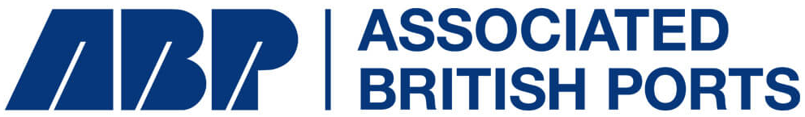

PORT OF SOUTHAMPTON

PORT USERS’ INFORMATION AND NAVIGATION GUIDELINES
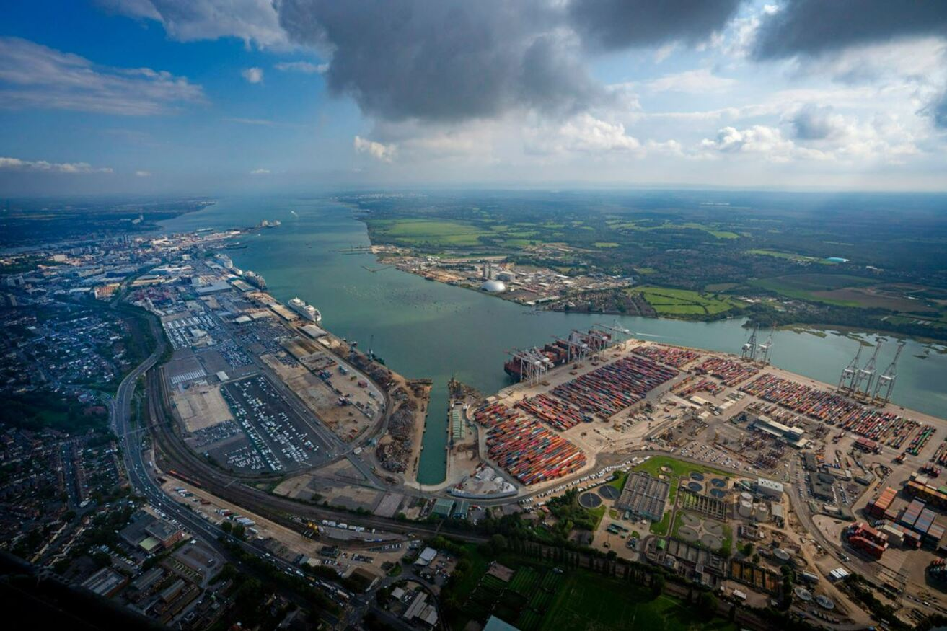

Review/Approval History
Version | Date | Reason for Update | Updated by | Signed Off by
1.5 | 07/10/2025 | Section 4  Clearances for manoeuvring category 3 container ships.  Clearances for feeder vessels to SCT 1 and minimum distance to adjacent vessel  Cat 0 Vessels Towage Criteria, Wind Parameters and SCT1 positioning updated  Amendment to LNG vessel ETA timings in Berths 43 to 47 (Ocean Dock) criteria.  Vessel max LOA for Marchwood Wharf.  SGL3 Tidal clarification for Berthing/unberthing and max LOA  Berth 30 to 33 Wind parameters table updated | LS | SM
1.6 | 30/10/2025 | Section 1  Navigation in restricted visibility. Removed duplication.  Section 4  SGL Wind Parameter table to align with recent Risk Assessment  SGL clarifications on Quarter Ramp and Non- Quarter Ramp vessel parameters  SGL Towage criteria to align with recent risk assessment | LS | SM
All amendments are inputted in red text.
Review/Approval History 2
Introduction 8
1 Navigation Guidelines 14
1.1 Condition of Vessels 14
1.1.1 Seaworthiness 14
1.1.2 Fuel Types used in CHA 14
1.1.3 Manoeuvring Equipment 14
1.1.4 Shaft Power and Engine Power Limitation systems 15
1.1.5 Testing of Astern Propulsion 15
1.1.6 State of Readiness of Vessels Alongside 15
1.1.7 Anchors to be cleared away 15
1.2 Restricted Visibility Guidelines 15
1.2.1 Navigation in Restricted Visibility 16
1.2.2 Guidelines When Visibility is Less Than 2 Nautical Miles 17
1.2.3 Guidelines When Visibility is Between 1 Nautical Mile and ½ a Nautical Mile 17
1.2.4 Guidelines When Visibility is Less Than ½ Nautical Mile (5 cables) 18
1.2.5 Guidelines When Visibility is Less than 2 Cables 18
1.3 Passage Planning Guidance 19
1.3.1 Southampton VTS Passage Planning 19
1.3.2 Standard Passage Planning Times 19
1.3.3 Abort Berths 19
1.3.4 Port Marine Safety Code and Passage Planning 19
1.3.5 Utilisation of Passage Plans 20
1.3.6 Pilot / Master Exchange of Information 20
1.3.7 Portable Pilot Units 21
1.3.8 Passage Planning Depths 21
1.3.9 Under Keel Clearance When Underway 21
1.3.10 Passing Moored Vessels 23
1.3.11 Overhead Bridge Clearances 24
1.3.12 Anchoring in the Southampton VTS Area 24
1.4 Navigational Channels 24
1.4.1 Precautionary Area, Moving Prohibited Zone, and Clear Channel Vessels 24
1.4.2 Clear Channel Vessels 24
1.4.3 Southampton Patrol 25
1.4.4 Thorn Channel 25
1.4.5 Nab Deep Water Channel 26
1.4.6 Turning Points 26
1.5 Passing Points 27
1.5.1 Passing Points within Southampton CHA 27
1.5.2 Passes to be Confirmed Upon Pilot Boarding 28
1.5.3 Solent Passes 28
1.5.4 Fawley Passes 28
1.5.5 Above Hook Pass 30
1.5.6 Above Cadland Pass 30
1.5.7 Dock Head Pass 30
1.6 Vessels Passing During Passenger Operations 31
1.7 Vessel Berthing and Unberthing 31
1.7.1 Self-Mooring 31
1.7.2 Weighted Heaving Lines 32
1.7.3 Use of Bow and Stern Thrusters 32
1.7.4 Moorings to be Tended 33
1.7.5 Airbridges 33
1.7.6 Shore Cranes 33
2 Vessel Traffic Services 35
2.1 Introduction 35
2.2 VTS – Contact details 35
2.2.1 General Enquiries 35
2.2.2 Contacting Southampton VTS by VHF 36
2.3 Vessels Not Ready to Move at the Agreed Time 36
2.4 Assistant Harbour Master (Vessel Traffic Services) 37
2.5 Reporting of Vessel Movements 37
2.5.1 Inbound VHF Reporting 37
2.5.2 Outbound VHF Reporting 38
2.5.3 Vessels Proceeding to/from Anchor 39
2.5.4 Vessels Proceeding to or from Ports within the Southampton VTS Area 39
2.5.5 Port Operation Channels 40
2.6 Mandatory Reporting Requirements 40
2.6.1 Bunkering Operations 40
2.6.2 LNG Bunkering 41
2.6.3 Outboard Operations Including Slewing of Cranes & Davits 41
2.7 Port Planning 42
2.7.1 ABPnotify – Online Vessel Booking System 42
2.7.2 Notice Periods 42
2.7.3 Accuracy of Declared Information 42
2.7.4 CERS 42
2.7.5 EDIFACT 43
2.7.6 ISPS Reporting 43
2.7.7 Dangerous Goods 43
2.7.8 Dangerous Goods - Notice of Entry 43
2.8 Sources of Meteorological Information 44
2.9 Emergency Plans/Procedures 44
2.9.1 Solent Maritime Framework 44
2.9.2 Port of Southampton Emergency Plan 44
2.9.3 Port of Southampton Oil Spill Contingency Plan 45
2.9.4 Portsmouth and Southampton Reactor Emergency Plan 45
3 Pilotage 48
3.1 Pilotage Directions 48
3.2 Pilot Embarkation / Disembarkation Positions in the Solent: 48
3.3 Notice of Pilotage Requirements 49
3.4 Duty Pilot 50
3.5 Pilotage Limits 50
3.6 Pilot Ladder Safety 50
3.6.1 Pilot Boarding in Adverse Conditions 50
3.7 Pilot Exemption Certificates 51
3.8 Pilotage Charges 52
3.8.1 BP Specialist Pilotage 52
3.8.2 Container Specialist Pilotage 52
3.8.3 ESSO Specialist Pilotage 52
3.8.4 KGV Assistant Pilot 52
4 Terminal, Berth, and Towage Information 54
4.1 Towage Introduction 54
4.1.1 General Towage Guidance 55
4.1.2 Accompanying Towage 55
4.1.3 Ship Assist Towage Bollard Pull 56
4.1.4 Non-Routine Towage 56
4.1.5 Routine Towage 56
4.2 Berthing and Mooring Guidance 57
4.2.1 Offshore Wind Speeds 57
4.2.2 Safe use of Mooring Launches in Docks 57
4.2.3 State of Readiness of Berths 58
4.2.4 Vessel Categorisation 58
4.3 Terminal Information 59
4.3.1 Guidance to Berth Operators 59
4.3.2 Large Tankers Time of Arrival at Hook Buoy 62
4.3.3 Fawley Marine Terminal 62
4.3.4 Fawley Power Station 69
4.3.5 BP Jetty Hamble (BPJ) 70
4.4 Eastern Docks 72
4.4.1 Berths 20 to 27 (Empress Dock) 72
4.4.2 Berths 30 to 33 73
4.4.3 Berths 34 and 35 75
4.4.4 Berth 36 77
4.4.5 Berths 38 to 42 78
4.4.6 Berths 43 to 47 (Ocean Dock) 79
4.4.7 Berthing of Cruise Vessels 82
4.4.8 Berths 48 to 49 83
4.5 Western Docks 84
4.5.1 Berths 101 to 107 84
4.5.2 Berths 108 and 109 86
4.5.3 110 Berth 87
4.5.4 King George V Dock 88
4.6 Dubai Ports World Container Terminal 90
4.6.1 Towage Criteria 90
4.6.2 Wind Parameters 92
4.6.3 Under Keel Clearance (UKC) Whilst Alongside 92
4.6.4 Additional Information 92
4.6.5 Ship Categories 93
4.6.6 Additional control measures for a new class or category of vessel 93
4.7 ABP Solent Gateway Ltd (SGL) 98
4.8 River Itchen Berths 101
4.8.1 Princes Wharf 101
4.8.2 Saxon Wharf (Upstream Side of Jetty) 102
4.8.3 Dibles Wharf 103
4.8.4 Dibles Gut 104
4.8.5 Crown and Leamouth Wharfs 104
4.8.6 Burnley Wharf 105
4.9 River Test 106
4.9.1 Marchwood Wharf 106
4.9.2 Cracknore (Ex Husbands) Jetty 107
4.9.3 Solent Refit – Hythe 107
5 Figures and Images 108
5.3 Precautionary Area (Moving Prohibited Zone) 111
5.4 Standard Passage Planning Times 112
5.5 Estimated Bollard Pull Required (Chart) 113
5.6 Cross Section of KGV Dock 114
5.7 Wind Speed Criteria at FMT 115
5.8 DPW Crane Information 116
5.8.1 Diagrams 116
5.8.2 Table 116
5.9 SCT4 Distances to 203 Corner 117
5.10 Solent Refit – Hythe Berth Depth Illustration 118
5.11 Fawley Mooring Plan Examples 119
5.11.1 FMT - Mooring Plan for Vessels Less Than 4,000 DWT 119
5.11.2 FMT - Mooring Plan for vessels 4,000 - 8,000 DWT (Version 1) 119
5.11.3 FMT - Mooring Plan for vessels 4,000 - 8,000 DWT (Version 2) 119
5.11.4 FMT - Mooring Plan for Vessels 8,000 – 12,000 DWT (Version 1) 119
5.11.5 FMT - Mooring Plan For Vessels Greater Than 12,000 DWT (Version 1) 120
5.11.6 FMT - Mooring Plan for Vessels Greater than 12,000 DWT (Version 2) 120
5.11.7 FMT - Mooring Plan for Vessels Greater Than 12,000 DWT (Version 3) 120

Introduction
Definitions and Abbreviations
Assistant Harbour Master (AHM) | The duty representative of the Southampton Harbour Master operating from Southampton VTS
Berth Operator | A person or company licenced to operate a berth, terminal, or marina within the Port of Southampton’s SHA.
Clear Channel Status | A vessel can request this when a clear and unimpeded channel is required.
Competent Harbour Authority (CHA) | A Harbour Authority which has statutory powers in relation to the regulation of vessel movements and the safety of navigation within its harbour; and whose harbour falls wholly or partly within an active former pilotage district.  A competent harbour authority (CHA) is a body with the statutory power to regulate shipping movements and provide pilotage services within a specific maritime harbour. These authorities are responsible for ensuring navigational safety, and in the UK, they have specific legal duties under the Pilotage Act 1987 as amended by the Marine Navigation Act 2013
ConRo | Vessels carrying both RoRo cargo and containerised cargo
Convention on the International Regulations for Preventing Collisions at Sea  (COLREGs) | International Regulations for Preventing Collisions at Sea which apply to all vessels upon the high seas and all waters connected to the high seas and navigable by seagoing vessels.
Harbour Master  (HM) | A person appointed by the harbour authority in accordance with the Harbours, Docks, and Piers Clauses Act 1847.
Large Vessel | A Large Vessel is defined as a vessel whose LOA is equal to or greater than 220 metres.
Maritime and Coastguard Agency  (MCA) | A government agency who produces legislation and guidance and provide certification to vessels and seafarers. Through their survey and inspection regime, they enforce standards for vessel safety, security, pollution prevention and seafarer health, safety, and welfare. They promote maritime standards, encourage economic growth, and minimise the maritime sector’s environmental impact.
MarNIS | ABPmer's port assessment toolkit, MARNIS, provides a pro-active approach to risk management, helping a port authority, Harbour Master or Port Safety Manager meet and exceed industry standards on risk management.
Moving Prohibited Zone  (MPZ) | Means an area extending 1000 metres ahead and 100 metres either side of any vessel of over 150 metres length overall while it is navigating within the Precautionary Area.
Pilot | A person duly authorised by the Harbour Master under section 3 of the Pilotage Act 1987, to provide pilotage services as defined in the pilotage directions.
Pilot Exemption Certificate  (PEC) | a pilotage exemption certificate issued to a bona fide Deck Officer in accordance with the pilotage directions.
Port and Vessel Information System  (PMIS) | A vessel planning and port management software used by Associated British Ports.
Portable Pilot Unit  (PPU) | A portable navigational aid used by Pilots.
Precautionary Area | The main navigable channel which lies between an imaginary line drawn between Prince Consort and South Bramble Buoys and an imaginary line drawn between Black Jack and Hook Buoys. See Admiralty Chart 2036.
RORO | Vessels carrying Roll-On-Roll-Off cargoes. i.e. Cars, Trucks
Southampton Container Terminal (SCT) | Consists of berths SCT 1 – SCT 5 operated by DPW (Dubai Ports World)
Southampton Patrol  (SP) | A Patrol Launch employed by the Harbour Master to enforce the harbour authorities’ rules and regulations.
Southampton Port Marine Users Group  (SPMUG) | A group of port stakeholders established for the Harbour Authority to be able to consult on matters around the safe operation of the Statutory Harbour Authority.
Statutory Harbour Authority (SHA) | Statutory Bodies responsible for the management and running of a harbour. The powers and duties in relation to a harbour are set out in local Acts of Parliament or a Harbour Order under the HA 1964
Vessel Traffic Services  (VTS) | Vessel traffic services (VTS) are shore-side systems which range from the provision of simple information messages to vessels, such as position of other traffic or meteorological hazard warnings, to extensive management of traffic within a port or waterway.

Purpose
The following guidelines have been established by, and agreed between, the Port of Southampton Harbour Master, CHA Pilots and members of the Southampton Port Marine Users Group (SPMUG). These guidelines supersede all previous versions and amendments.

Where marine activities cross between the SHA’s of Southampton, Portsmouth, Cowes, Hamble, and areas under management of the MCA, a Memorandum of Understanding is in place for all Harbour Masters and Government Agencies to jointly manage the effects of vessel traffic and other marine activities. Certain provisions within these guidelines refer to areas outside of the Port of Southampton SHA limits but within the Southampton VTS area. Such provisions apply to all vessels regardless of their port of arrival/departure. A map of the relevant areas can be found in Section 5.

The Harbour Master is responsible for:
- The provision of Vessel Traffic Services within a part of the Dockyard Port of Portsmouth and a part of the Territorial Sea, under an agreement with the King’s Harbour Master Portsmouth and the Maritime and Coastguard Agency. See Section 5

- The provision of pilotage services within the Southampton Competent Harbour Authority limits. See Section 5

Section 52 of the Harbours, Docks, and Piers Clauses Act 1847 sets out the powers of a Harbour Master. The Harbour Master may give direction for the following purposes:

- For regulating the time at which and the manner in which any vessel shall enter into, go out of, or lie in or at the harbour, dock, or pier, and within the prescribed limits, if any, and its position, mooring or unmooring, placing, and removing whilst therein.

- For removing unserviceable vessels or other obstructions from the harbour, dock, pier and keeping the same clear.

The information contained in these guidelines is intended to bring to your attention the requirements considered necessary for the Harbour Master to fulfil these responsibilities.

Promulgation of Navigational Information
The 2003 Port of Southampton Harbour Byelaws are published separately and should be read in conjunction with these guidelines.

Where it is necessary to update, temporarily modify or supersede any of the guidance contained herein, the Harbour Master will publish a Local Notice to Mariners. Local Notices to Mariners may also be used to inform port users of important navigational information and should be read in conjunction with these guidelines.

Issues which are of concern only to a specific group of port users may, instead, be promulgated in the form of a Harbour Master’s General Marine Notice. These are, typically, restricted to an internal distribution within the port authority but may, on a case-by-case basis, be shared with other port users.

These guidelines, Harbour Byelaws, Local Notices and Mariners and further information on the port can be found at www.southamptonvts.co.uk.

Review
These guidelines shall be reviewed and amended periodically as determined by the Harbour Master. Any deviations from these guidelines must be consulted with the Harbour Master or a person with delegated powers of the Harbour Master.

SECTION 1

NAVIGATION GUIDELINES

Navigation Guidelines

Condition of Vessels

Seaworthiness
Vessels manoeuvring within the Southampton VTS area should comply with all applicable legislation to ensure that the vessel is in all respects seaworthy and safe to conduct its passage.

Fuel Types used in CHA
The port of Southampton is within the North Sea Emission Control Area as defined by MARPOL Annex VI: Prevention of air pollution by ships.

Ships must carry a written procedure showing how the changeover from one fuel to another is carried out. The changeover must allow sufficient time for the fuel oil system to be fully flushed out of any non-compliant fuel before entering an emission control area.

Ships using exhaust gas cleaning systems (EGCS) to comply with the ECA sulphur limit, often referred to as a ‘scrubber’, are to be operated in accordance with IMO guidelines. The latest environmental guidance can be found on www.southamptonvts.co.uk.

Vessels planning to operate on alternative fuels within the CHA, such as Electric (or Hybrid systems), Hydrogen, LNG, Methanol, Nuclear or Ammonia are to notify Southampton VTS 24 hours before arrival.

Manoeuvring Equipment
The vessels master should ensure that all manoeuvring and mooring equipment is checked prior to arrival at the pilot station or departure from the berth to ensure that it is fully operational. Any defects should be reported to Southampton VTS.

Shaft Power and Engine Power Limitation systems
Should a vessel be using Shaft Power (SHaPoLi) or Engine Power Limitation (EPL) systems within the CHA the port must be notified 24 hours prior to arrival. The pilot must be made aware of such systems and their possible impact on immediate access to full manoeuvring power.

Testing of Astern Propulsion
All vessels are expected as part of pre-arrival or pre departure checks are required as a minimum to carry out astern propulsion checks.

Southampton VTS must be notified on VHF Channel 12 prior to propulsion tests being conducted within the SHA.

State of Readiness of Vessels Alongside
Any work which will render the vessel immobile must not be commenced without the approval of the Southampton VTS and the berth operator. Vessels wishing to immobilise must inform the Southampton VTS before they do so.

Anchors to be cleared away
All anchors must be cleared away prior to approaching pilot stations where safe to do so. VTS is to be informed if this is not possible.

Prior approval must be sought from VTS if a vessel wishes to use anchors for berthing manoeuvres.

Vessels are not permitted to deploy anchors whist alongside a berth without permission from Southampton VTS and the berth operator.

Restricted Visibility Guidelines
The following guidelines are intended to provide assistance to mariners navigating within the Southampton VTS area (see Section 5) when visibility is restricted.

Navigation in Restricted Visibility
Navigating a vessel in restricted visibility requires a full understanding of the COLREGS. Pilots and PEC holders are also reminded of the contents of the Marine Guidance Note (MGN) 369 “Navigation in Restricted Visibility”.

In restricted visibility Southampton VTS will endeavour to disseminate relevant traffic information in good time as such identifying small craft where possible and informing vessels in the vicinity of such small craft in order to prevent a close quarters situation developing and a risk of collision occurring. Pilots and PEC holders are reminded not to place over reliance on the service of VTS and to ensure they are using all available means when ascertaining local traffic conditions.

- Although the use of AIS as an additional aid to situational awareness in restricted visibility is an accepted good practice it should be remembered that not all small craft will be fitted with AIS and that any information received should not be used for collision avoidance. This reinforces the need for a proper radar watch to be maintained at all times.

- If the Harbour Master has reason to believe that a vessel may not be equipped to enter, leave, or transit the area safely in restricted visibility, he may direct the vessel to an outer anchorage or instruct it to remain alongside.

In the event that these guidelines require a broadcast to be made by VTS, the broadcast shall be made on VHF, Channel 14, preceded by a ‘Securite’ announcement on VHF, Channels 16 & 12, to warn mariners in the VTS area of the presence, or likely presence of restricted visibility.

If visibility is only restricted in small parts of the VTS area, it will be for the Harbour Master, Pilot and Vessels Master to determine the extent to which this routine should be implemented.

A ‘clear channel in fog’ vessel is one that is deemed to require a Moving Prohibited Zone.

If the Harbour Master has reason to believe that a vessel may not be equipped to enter, leave, or transit the area safely in restricted visibility, they should direct the vessel to an outer anchorage or instruct it to remain alongside.

Guidelines When Visibility is Less Than 2 Nautical Miles
In the event of the AHM being made aware that the visibility is less than 2 nautical miles, either through visibility sensor equipment or a report received from a vessel within the area, they shall take the following action:

- Call the contracted meteorological forecaster for a prognosis.

- Issue a ‘Visibility Warning’ broadcast detailing the current visibility and an indication of the forecasted trend.

- Request further visibility reports from other vessels to determine the extent of the reduced visibility.

- Ensure that arriving/departing vessels are kept informed of current conditions and identify possible abort berth/anchorages.

- Ensure that, prior to boarding, Pilots are informed of current visibility conditions and that Launch Coxswains are also kept advised accordingly.

- Review planned passes of vessels taking into account any observed or forecasted deterioration in visibility.

Guidelines When Visibility is Between 1 Nautical Mile and ½ a Nautical Mile
The AHM shall ensure all the above measures have been taken and in addition:
- Calshot/Hook fog signals must be switched on when visibility in the Fawley/Thorn Channel area is less than 1 nautical mile.

- High speed ferries when operating in reduced visibility of less than 1 nautical mile must report to Southampton VTS when passing the Hook Buoy.

- Ryde/Fishbourne/Portsmouth/Southsea Ferries must, when visibility between the Forts and Ryde Middle is below 1 nautical mile, call Southampton VTS on leaving Southsea/Swashway (Southbound) and Ryde/Fishbourne (Northbound).

- Both radar surveillance desks in the VTS Centre should be permanently staffed.

- Advice on a vessel’s position should, in general, be given as a bearing and distance from a known point.

- Vessels planned to use Pilot Station Foxtrot will now use Pilot Station Echo.

- All vessels whose LOA is greater than or equal to 150 metres shall have ‘Clear Channel Status’ where a Moving Prohibited Zone is in place when transiting the precautionary area.

- Pilots or PEC Holders of vessels less than 150 metres LOA may request ‘Clear Channel Status’ in the Precautionary Area.

- Transits of the River Itchen above the Itchen Bridge should not be undertaken.

- Laden vessels carrying dangerous or polluting goods in bulk (60,000t DWT or greater) will not normally proceed inwards past the West Bramble buoy or depart from their berth.

- Fawley and Dock Head Passes shall not be planned if the visibility is forecast to remain at this level or lower.

- No vessel shall be permitted to leave a berth or enter Southampton VTS Area if, in the consideration of the Harbour Master, it is likely to place one or more vessels at unnecessary risk. In these circumstances the time/manner of entry into port limits shall be adjusted as considered appropriate and the vessel directed accordingly.

Guidelines When Visibility is Less Than ½ Nautical Mile (5 cables)
The AHM shall ensure all the above measures have been taken and in addition:

- Laden vessels carrying dangerous and polluting cargoes in bulk, or vessels which are neither gas free nor inerted should not normally enter an area in which the visibility is less than ½ a nautical mile.

- No vessel will be given dispensation to exceed the six-knot speed limit northward of the line between Hythe Pier and the Weston Shelf buoy.

- All vessels within the Southampton SHA (see Section 5) that are confined to navigating only within a navigable channel will be given a ‘clear channel’ status.

- Ship Assist Tugs authorised for use in the Port of Southampton will no longer be exempt from the “clear channel” rules.

Guidelines When Visibility is Less than 2 Cables
Tugs may have difficulty making fast, in particular on the bow, in visibility of less than 2 cables. The decision to make fast will rest solely with the Tug Master.

- Inward vessels requiring tug assistance should consider carefully whether the probability of the visibility reducing to less than 2 cables is such that an abort should be considered before passing the West Bramble buoy.

- Inward vessels of 220m LOA or greater requiring tug assistance should consider carefully whether the probability of the visibility reducing further is such that an abort should be considered before passing the West Ryde Middle buoy and committing the vessel to the inward passage.

- Should a vessel requiring ship assist towage, once committed to entering Southampton Water, experience a further reduction in visibility, it must be understood that whilst the dock tugs will endeavour to assist the decision to make fast will rest solely with the tug master.

- All bunkering operations must cease, and hoses cleared of marine pollutants when vessels of over 150 metres LOA pass.

Passage Planning Guidance

Southampton VTS Passage Planning
Southampton VTS is to ensure that the movements of all vessels are monitored throughout their passage and that they are advised of all necessary information relating to the movement of other vessels and their own navigational requirements.

The Master and Pilot, in conjunction with Southampton VTS, will agree a passage plan including the following four key details:

- ETAs at various locations throughout the intended route.

- Co-ordination of passing arrangements with other vessels.

- Abort points on the planned passage.

- Other planned vessel movements.

Standard Passage Planning Times
A table of standard passage planning times is given in Section 5. These timings are to inform vessel booking and advanced planning. Actual passage times may be amended by the Assistant Harbour Master (VTS), Duty Pilot or Conducting Pilot(s) to take into account variables that are summarised in Section 5.

Abort Berths
Where weather or tidal conditions are marginal for vessels manoeuvring an abort berth should be considered. If no abort berth is available consideration should be given to aborting at sea.

Port Marine Safety Code and Passage Planning
The Harbour Master’s powers to regulate the time and manner of a vessel’s entry to, departure from and movement within their waters serve to complement port passage planning. Passage plans are to be operated and enforced as an adjunct to the powers of direction.

The object of port passage planning guidance, as required by the Port Marine Safety Code, is to ensure that:

- All parties know relevant details of any particular port passage in advance.

- There is a clear, shared understanding of potential hazards, margins of safety, and the vessel’s characteristics.

- Intentions and required actions are agreed for the conduct of the port passage – including the use of tugs and their availability – and any significant deviation should it become necessary.

Utilisation of Passage Plans
All vessels manoeuvring within the CHA limits of the Port of Southampton, whether piloted or navigated by a PEC holder, must prepare and utilise appropriately detailed port passage plans in accordance with International Chamber of Shipping Guidelines and in conjunction with IMO Resolution A.893(21). The vessel’s bridge is to be properly manned as required by regulation 11/1 of the STCW Convention.

Pilot / Master Exchange of Information
The careful planning of the movement of vessels in the CHA is an essential element of the port’s Safety Management System.

The Pilot / Master exchange of information needs to be both detailed and structured. Information supplied by VTS and the Pilot’s and vessel’s passage plan, are to be integrated to ensure that both the Pilot and Master have the information needed for an agreed port passage plan.

A passage plan should, as a minimum, include:

- The provision of relevant VTS traffic information and agreed passage timings.

- Detailed local navigational knowledge such as the number of tugs to be used, intended berth, side to quay, mooring arrangements and minimum UKC. It should also include a recommended passage plan.

- The provision by the Master of precise information about the vessel, its manoeuvring characteristics and its equipment including details of any defects.

Portable Pilot Units
The CHA has issued each Southampton Pilot with a Portable Pilot Unit (PPU) and produced a policy for its use. When a PPU is required as a function of a risk assessment then a Type 1 PPU should be utilised.

The CHA expects pilots to use all available means to determine the vessel’s position and not rely exclusively on one piece of equipment. As such, the PPU should be considered to be an aid to navigation.

The vessel’s bridge team is reminded of its duty to maintain an accurate check on the vessel’s position as laid down in the ISM Code, STCW Convention, IMO Regulations & ICS Bridge Procedure Guide.

Passage Planning Depths
All berths in the Port of Southampton are liable to siltation. Berth operators are responsible for ensuring their berths are regularly surveyed and any changes to the advertised depth notified to the Harbour Master. The port authority regularly surveys the channels in the port and its approaches.

A summary of all berth and approach channel advertised and actual depths is published regularly by the port’s hydrographic department and is available from www.southamptonvts.co.uk.

Under Keel Clearance When Underway
ABP have produced the below guidelines for the minimum under keel clearance within the competent harbour authority, for vessels underway. Where percentages are given, this is a percentage of the vessels static draft.

For under keel clearances whilst alongside berths please refer to Section 4.

Dynamic effects on a vessels draft such as squat, heel and wave response are to be determined by the conducting pilot or PEC holder. When calculating under keel clearance pilots/masters should take note of the short duration of ebb tide and the potential rapid fall in tidal heights from 3.5 hours before low water, especially on spring tides.

Pilots and Masters may require additional under keel clearance from what is shown in the tables below. Where this may affect the typical route taken by the vessel (e.g. Nab Deep Water channel), VTS must be advised.
Vessels with shallow drafts may consider reducing their minimum UKC requirements if safe to do so.

Vessels requiring specialist pilotage:
 | Container Vessel |  |  |  |  | Tanker
 | Category 7 | Category 6 | Category 5 | Category 4 | Category 2 and 3 | >60,000 DWT
Nab Channel | 2.20m | 2.00m | 2.00m | 1.80m | 1.80m | 1.50m
East of New Grounds | 2.20m | 2.00m | 2.00m | 1.80m | 1.50m | 1.50m
Thorn Channel | 2.00m | 2.00m | 1.80m | 1.80m | 1.80m | 1.50m
Southampton Docks | 1.50 metres or 10% of vessels static draft, whichever is greater

- Under Keel Clearance for vessels greater than 60,000 tonnes to or from BPJ should have minimum 1.00 metre on approaches.
All other vessels subject to compulsory pilotage (including tankers <60,000 DWT) Unless otherwise stated within the berthing criteria (Section 4):
All other vessels subject to compulsory pilotage (including tankers <60,000 DWT) Unless otherwise stated within the berthing criteria (Section 4)
Nab  to  Hythe Line | 1.50 metres or 10% of vessels static draft, whichever is greater
North Channel | 1.00 metre on a flood tide  1.50 metres on an ebb tide
Fawley Power Station | 0.30 metres of vessels static draft on a flood tide  0.50 metres of vessels static draft on an ebb tide
Fawley Marine Terminal | 0.50 metres or 10% of vessels static draft, whichever is greater
BP Jetty Hamble | 1.00 metres or 10% of vessels static draft, whichever is greater
Solent Refit | UKC equal or greater 0.60 metres
Hythe Line  to  SCT1 / 30 Berth | 0.60 metres or 10% of vessels static draft, whichever is greater
Empress Dock | 0.60 metres of vessels static draft
Itchen River  North of 30 Berth | 0.30 metres of vessels static draft on a flood tide  0.50 metres of vessels static draft on an ebb tide

Passing Moored Vessels
Due care should be taken when passing moored vessels within the port. A sufficiently wide berth must be given at a safe minimum speed possible to maintain steerage way. If the prevailing weather or tide conditions dictate, the use of a tug should be considered when passing in close proximity to other moored vessels.

Overhead Bridge Clearances
This table gives the height above chart datum of the lowest point at the centre of the middle arch of each bridge in the port area.

Name of Bridge | Height Above
Name of Bridge | Chart Datum | H.A.T | Minimum Clearance
Itchen Bridge | 28.9m | 23.0m | 0.50m
Northam Bridge | 9.2m | 4.2m | -
Railway (Itchen) | 9.0m | 4.0m | -
Cobden Bridge | 9.1m | 4.1m | -

Anchoring in the Southampton VTS Area
Numerous cables, pipelines and underwater obstructions exist in the Southampton VTS area. Any vessel intending to anchor must contact Southampton VTS on VHF Channel 12 before dropping their anchor to obtain permission.

Navigational Channels

Precautionary Area, Moving Prohibited Zone, and Clear Channel Vessels
Additional details on the Precautionary area and Moving Prohibited Zone are issued as a Southampton Local Notice to Mariners.

Clear Channel Vessels
All vessels whose LOA is greater than 220 metres navigating between the Hook Buoy and the Prince Consort Buoy shall be given a “clear channel in the precautionary area”, defined as:

“A clear and unimpeded passage ahead when transiting the Precautionary Area”

Vessels may enter the Precautionary Area maintaining a safe distance astern of a ‘clear channel’ vessel (See Section 5).

A vessel subject to compulsory pilotage may request a “clear channel”. This will be promulgated by Southampton VTS on VHF Channel 12.

Ship Assist Tugs authorised for use within the Port of Southampton, as per Local Notice to Mariners, may navigate within the Precautionary Area when clear channel vessels are also in this area provided that the tug:
- does not impede the clear channel vessel.
- must request traffic clearance from Southampton VTS in agreement with clear channel vessel.
- This does not apply during periods of restricted visibility.

Southampton Patrol
Southampton Patrol (call sign “SP”) will be available to patrol vessels over 180m LOA when navigating in the Precautionary Area.

In the event of SP being unavailable for patrol duties in the Precautionary Area, cover may be sourced from the Nab Launches.

Thorn Channel
Inbound vessels greater than or equal to 180m LOA shall not enter the Thorn Channel unless the following criteria are observed:

- A berth or an abort procedure is in place for the vessel.

- Whatever assistance the vessel requires to berth – tugs, mooring gang, etc. are available and will remain so throughout berthing.

- Passing points with other vessels have been coordinated and agreed.

Two vessels whose LOA is greater than or equal to 180 metres shall not pass or overtake each other between the Hook Buoy and a line drawn due south of West Bramble Buoy.

A second inbound vessel whose LOA is greater than or equal to 180 metres will not normally be planned to pass Prince Consort Buoy until:

- An inbound vessel whose LOA is greater than or equal to 180 metres bound for Southampton Docks has passed the Reach Buoy. In normal conditions this requirement can be relaxed to a separation of 15mins for Passenger Vessels where a high degree of machinery redundancy exists.

- An inbound tanker whose LOA is greater than or equal to 180 metres for the Fawley or BP Oil Terminals is in a controlled situation with tugs secured.

Nab Deep Water Channel
The Nab Deep Water Channel is primarily for vessels constrained by their draught, and which can only navigate safely within that channel. Vessels not requiring the Nab Deep Water Channel, should keep well clear of the channel and not impede vessels which require to use it.

- Outward bound vessels which require the use of the Nab Deep Water Channel must inform Southampton VTS when passing the Hook Buoy and at the Forts reporting point.

- When a vessel, requiring the use of the Nab Deep Water Channel, is navigating in the channel no other vessel shall overtake, pass, or cross ahead of the vessel within the confines of the channel.

- Where no deep drafted vessel is required to use the channel, any other vessel may request its use from Southampton VTS.

Turning Points

West Bramble Turn Navigational Assistance
All vessels greater than 220 metres LOA shall inform Southampton VTS of their planned turning point at the West Bramble turn and, on request, at the Calshot turn. The vessel should establish communication with the AHM on a dedicated radio frequency before passing the Prince Consort Buoy.

- Inward bound vessels will be offered a “Count Down”.
- Inward bound, the West Bramble turning point should be related to the distance to run to the Gurnard Buoy.
- Inward bound, the Calshot turning point should be related to the Calshot Spit Lightfloat / Castle Point Buoy transit.

- On approaching each turning point, the vessel will be advised by the AHM of the distance to run at one cable intervals. An indication of left or right of track may also be given.

- The Pilot will inform the AHM when commencing the turn.

- All vessels are to issue sound signals as defined in COLREGS to indicate directional change turns.

- The Pilot will make use of all available sea room when making the West Bramble turn.

West Bramble Turn Maximum Wind Speeds for Inbound Vessels
The Pilot and AHM should ensure that, when passage planning, due allowances are made for the vessel to be able to safely turn at the West Bramble taking into account sufficient reserve of speed in the prevailing weather and traffic conditions.

This is dependent on sufficient towage being available in the Docks area to allow the vessel to berth safely on arrival.

It is recommended that, at the West Bramble turn, the maximum mean wind speed (in the South West Quadrant) for container ships ≥180m LOA is as follows:

Mean Wind Speed (knots) as measured at Bramble Pile (≈10m CD)
LOA | Wind Speed | Wind Direction | Draught | Restrictions and Mitigations
<180m | All | All | Both | At the discretion of the Master and Pilot
≥180m | >30 | All | <11m | Outside of recommended limits
≥180m | >35 | All | ≥11m | Outside of recommended limits

Passing Points

Passing Points within Southampton CHA
The below passing points are for vessels planned to pass whose LOA is equal to or greater than 180 metres. Passes shall be planned and agreed by the AHM, and the Pilots concerned before the acts commence.

It will be the responsibility of the vessels involved to advise each other, as well as Southampton VTS, of any alterations to their timings. This is of particular importance where a vessel’s transit time will be different to the standard timings used for planning by VTS.

Name | Description
Solent Pass | Vessels passing only to the East of the West Ryde Middle Buoy.
Fawley Pass | Vessels passing between the Hook and Cadland Buoys.
Above Hook Pass | A “Fawley Pass” where one of the passing vessels is due to berth at ESSO or BPJ,
Above Cadland Pass | Vessels passing in the main channel between the Cadland/Greenland buoys and Dock Head
Dock Head Pass | Vessels passing between the Pier Head and Western Shelf Buoys.

Passes to be Confirmed Upon Pilot Boarding
The VTSO (Pilots) shall, on allocation of a vessel whose LOA is equal to or greater than 180 metres, brief the Pilot on all relevant planned movements of other vessels including details of any passes.

These should be confirmed with the Pilot by Southampton VTS once the Pilot has boarded the vessel and thereafter updated as necessary.

Solent Passes
Vessels whose LOA is equal to or greater than 180 metres should be planned to pass port to port either north or south of the Ryde Middle Bank. Passes between the Prince Consort Buoy and the West Ryde Middle Buoy will be avoided.

Fawley Passes
The following factors shall be considered when planning a pass at Fawley,

- Adverse weather, tidal conditions, and depth of water.

- Vessels shall not be planned to manoeuvre on/off berths adjacent to the passing areas.

- Availability of separate cover for towage.

- The maximum total number of vessels involved in a pass shall be 3.

- Vessels with a “dead slow” speed exceeding 6 knots may be subject to additional traffic management.

- Fawley Passes are not permitted with container vessels utilising escort towage.

- Restrictions will apply to vessels of Container Category 4 and above as detailed below.

- FMT Marine Control Room are to be advised of Fawley Passes taking place involving vessels of category 4 and above.

- Tankers greater than 60,000 DWT should be fully secured before any Fawley Passes take place involving vessels of category 4 and above.

Tanker >60,000DWT alongside ESSO 1 to 5:
Container vessel category | Container vessel draught | Container vessel inbound | Container vessel outbound
7 | Any | No Fawley Pass with vessels >150m LOA | No Fawley Pass with vessels >150m LOA
6 | Any | No Fawley Pass with vessels >150m LOA | No Fawley Pass with vessels >150m LOA
5 | > 14m | No Fawley Pass with vessels >150m LOA | No Fawley Pass with vessels >150m LOA
5 | ≤ 14m | Fawley Pass permitted | Fawley Pass permitted
4 | > 14m | Fawley Pass permitted | No Fawley Pass with vessels >150m LOA
4 | ≤14m | Fawley Pass permitted | Fawley Pass permitted

No tanker >60,000DWT alongside ESSO 1 to 5:
Container vessel category | Container vessel draught | Container vessel inbound | Container vessel outbound
7 | Any | No Fawley Pass with vessels >150m LOA | No Fawley Pass with vessels >150m LOA
6 | Any | No Fawley Pass with vessels >150m LOA | No Fawley Pass with vessels >150m LOA
5 | > 14m | Fawley Pass permitted | No Fawley Pass with vessels >150m LOA
5 | ≤14m | Fawley Pass permitted | Fawley Pass permitted
4 | Any | Fawley Pass permitted | Fawley Pass permitted

Above Hook Pass
When an inbound tanker whose LOA is greater than or equal to 180 metres is bound for the Fawley or BP Oil Terminals, the Fawley pass is typically conducted south of Esso berth 5 and may require minor adjustment to the standard Fawley Pass timing.

Above Cadland Pass
A vessel greater than or equal to 180 metres LOA shall not normally pass another vessel greater than or equal to 150 metres LOA in the main channel between the Cadland/Greenland buoys and Dock Head. Instead, these vessels shall be planned to conduct a Fawley or Dock Head Pass.

Vessels of Container Category 4 and above may pass another vessel less than 150 metres LOA at the discretion of the Conducting Pilot and the Assistant Harbour Master (VTS).

Dock Head Pass
The following factors shall be considered when planning a pass at Dock Head:

- Adverse weather, tidal conditions, and depth of water.

- Vessels shall not be planned to manoeuvre on/off berths adjacent to the passing areas.

- Where vessels are using ship assist towage, separate tugs are to be allocated for each vessel. i.e. tugs for the inbound vessel must not be working the outbound vessel.

- Vessels on 38/39 and 40/41 Berth are to be advised of the intended pass.

The maximum total number of vessels involved in a pass shall be 2.

Vessels Passing During Passenger Operations
Container vessels of category 4 and above have significant displacements and are required to pass close to passenger vessels moored on berths 38/9 and 102 to 106. As a precaution against movement of the passenger vessel, causing damage or disconnection of the airbridge/gangway, the following procedure shall be followed when container vessels of category 4 and above are passing passenger vessels using an airbridge/gangway:

Input Parameters for SMS Messages

- Automated text message sent the Terminal Liaison Officer (TLO) alerting of an expected vessel passing which is Container Category 4 and above. This message is sent as the vessel approaches Dock Head bound for Southampton Container Terminal or as the vessel enters the Upper Swinging Ground originating from Southampton Container Terminal locations.

- TLO will appropriately holt passenger embarkation/disembarkation on all airbridges and gangways in preparation for the category 4 and above vessel passing.

- TLO to inform all necessary landside parties involved; Engineers, Ground Services, Operations Manager, etc.

- Once the vessel has passed, the TLO will authorise the resuming of embarkation/disembarkation operations.

Vessel Berthing and Unberthing

Self-Mooring
Masters and crews of vessels using the Port of Southampton are advised that self-mooring is not permitted within Southampton Docks including Solent Gateway Ltd, unless method statements and risk assessments have been provided and written approval is given from the Harbour Master.

Licensed mooring operators are required to assist with mooring operations for all vessels over 20 metres LOA.

This includes vessels over 20 metres LOA shifting on mooring lines.

Weighted Heaving Lines
Masters and crews are required to use properly constructed heaving lines for all mooring and towing operations. The use of ‘weighted' heaving lines is both illegal and dangerous and may cause serious injury or even death to those receiving the line. The Code of Safe Working Practices for Merchant Seamen, Chapter 25 (25.3.2) states:

Vessels’ heaving lines should be constructed with a ‘Monkeys Fist’ at one end. To prevent personal injury the ‘fist’ should be made only with rope and should not contain added weighting material.

Vessel’s mooring crews should always alert shore mooring gangs, tug crews or others in the vicinity prior to throwing a heaving line.

Masters are reminded that heaving lines with any added weighting material are not to be used under any circumstances and, if used, appropriate enforcement action will be taken. The following procedure is to be followed whenever a dangerously weighted heaving line is detected on the ABP estate:

- The weight is to be removed immediately and confiscated.

- The weight is to be replaced with a suitable replacement (“bean bag”) and a charge will be made to the vessel as per Port Tariff.

- The Master is to be re-issued with a notice explaining why the action has been taken.

- The incident is to be reported by Spot It, recorded in MarNIS, and reported to the MCA.

Use of Bow and Stern Thrusters
Masters of vessels should, whenever possible, utilise their thruster units in such a way as to minimize excessive wash.

The safety of all persons using the port, the protection of the marine environment and potential damage to quayside infrastructure (scour) are of paramount importance. Masters are, therefore, urged to avoid using more power on thruster units than required to safely manoeuvre their vessel.

Masters of vessels utilising thrusters whilst moored, must ensure thrusters are stopped in sufficient time so as to not adversely affect passing vessels.

Moorings to be Tended
The Master of a vessel which is berthed or moored in the Port of Southampton shall ensure that their vessel is securely made fast and that the moorings are adjusted as necessary to allow for the rise and fall of the tide and for the loading and unloading of cargo (Southampton Harbour Byelaws Part III No 18).

Masters of high-sided vessels berthed in Southampton are reminded of their responsibility to ensure that the vessel remains securely alongside when strong offshore winds are forecast and/or experienced. Measures to be considered include the adjustment of moorings as necessary, the correct use of tension winches, the use of additional moorings and tug(s) to push up.

Airbridges
All vessels with an air bridge in place shall ensure that their moorings are tightly secured at all times.

Specific procedures exist for moored vessels using an airbridge on berths 38/9 and 102 to 106 when a large container vessel is passing.

On departure, all moorings are to remain tightly secured until the air bridge has been fully removed and the airbridge is visibly clear of the vessel and the indication light is showing green.

Shore Cranes
When vessels are arriving or departing berths (other than at SCT) which have cranes at or close to the quay edge, the cranes shall be moved so as to be within the midships area of the vessel’s final position, or not less than 30 metres beyond the fore and aft extremities of the vessel. This is to minimize the risk of the vessel contacting the crane during its manoeuvre should the flare of the bow or stern pass over the quay edge.

SECTION 2

VESSEL TRAFFIC SERVICES

Vessel Traffic Services

Introduction
The Harbour Master monitors, co-ordinates and controls vessel movements through the establishment and operation of an IALA compliant Vessel Traffic Service (VTS), known as “Southampton VTS”.

Southampton VTS covers the Port of Southampton, The Solent, a part of the Dockyard Port of Portsmouth and a part of the Territorial Sea under an agreement with the King’s Harbour Master Portsmouth and the Maritime and Coastguard Agency. (See Section 5)

VTS procedures have been established in agreement with the stakeholders concerned to ensure continuity of communications and co-ordination of vessel movements. The IALA full description of Southampton VTS is available online at: www.southamptonvts.co.uk.

VTS – Contact details
The marine operations department of the Port of Southampton are based at:

Ocean Gate
Atlantic Way
Southampton
SO14 3QN

General Enquiries
The primary means of notifying Southampton VTS of a vessel movement is via the ABPnotify online portal.
Other enquiries should, in the first instance, be made by email. Urgent enquiries can be made by telephone.
Contact | Email | Telephone | Note
ABP Reception | reception@abports.co.uk | 023 8048 8800 | Monday – Friday  0900 to 1700
Harbour Masters Mailbox | HMSouthampton@abports.co.uk | 023 8060 8208 | Monday – Friday  0900 to 1700
VTS | southamptonvts@abports.co.uk | 023 8060 8208 | For information relating to movements and transits through the Southampton VTS area occurring in the next 24 hours
Port Planning | port.planning@abports.co.uk | 023 8060 8208 | For information relating to vessel bookings
Dangerous Goods | Sotondg@abports.co.uk | 023 8060 8208 | Monday – Friday  0900 to 1700
Berthing Officer | berthingofficers@abports.co.uk | 023 8060 8208 | For information on vessel berth allocations in Southampton Docks

Contacting Southampton VTS by VHF
Southampton VTS can be contacted by VHF radio on channel 12 - call sign “Southampton VTS”. Details on port operation channels can be found online at www.southamptonvts.co.uk.

Vessels Not Ready to Move at the Agreed Time
In cases where a vessel will not be ready to commence a movement within the VTS area at the agreed slot time the Master, vessel owner, agent or berth operator must inform Southampton VTS immediately.

The vessel must remain in its present position or proceed to a place of safety until a revised plan for the vessel’s movement has been agreed by the Assistant Harbour Master (VTS). Failure to comply may result in the vessel missing her allocated time slot thus resulting in delay due to other traffic movements, particularly in the case of large and/or deep draught vessels.

Assistant Harbour Master (Vessel Traffic Services)
The powers of the Harbour Master with respect to the direction of traffic movements are delegated to the Assistant Harbour Master (VTS). The Assistant Harbour Master (VTS) decision with respect to the direction of movement of any vessel is final.

Reporting of Vessel Movements
The master of any vessel exceeding 20 metres in length shall give reasonable prior notice to the harbour master of the vessel’s arrival at, departure from or movement within, the Port. These vessels must additionally report to the harbour master by VHF when passing reporting points as indicated on the Admiralty Chart. Please see Southampton Harbour Byelaws.

A reporting vessel which has had a movement notification approved by Southampton VTS may navigate within the VTS area complying, where necessary, with the applicable pilotage requirements. Whilst navigating in the VTS area, the vessel is required to continuously monitor VHF Channel 12 and report to Southampton VTS as follows.

Inbound VHF Reporting
Vessel Type | Reporting Point | Report to | VHF Channel No.
All Vessels Requiring a Southampton Pilot | 3 hours before arrival to the Pilot Station | ‘Southampton Pilots’ | 09
Vessels ≥20m LOA inward bound to the East of the Isle of Wight (Nab Approach) | 10 nautical miles or 1 hour from the Nab Tower | ‘Southampton VTS’ | 12
Vessels ≥20m LOA inward bound to the West of the Isle of Wight (Needles Approach) | 10 nautical miles or 1 hour from the Needles Fairway Buoy | ‘Southampton VTS’ | 12
Vessels ≥20m LOA inward via Nab Approach | When Passing  - Nab Tower  - No Man’s Land Fort  - South Ryde Middle buoy  - Hook buoy | ‘Southampton VTS’ | 12
Vessels ≥20m LOA inward via Needles Approach | When passing  - Needles Fairway  - Yarmouth Roads  - East Lepe buoy  - Hook buoy | ‘Southampton VTS’ | 12
Vessels ≥20m LOA whilst within the Southampton VTS Area | Once all fast at a berth or brought up to anchor | ‘Southampton VTS’ | 12
Vessels ≥20m LOA whilst within the Southampton VTS Area | 30min prior to weighing anchor | ‘Southampton VTS’ | 12

- Vessels using the needles approach should follow IMO Resolution A.768(18) section 3.6 Needles Channel Ships Routeing recommendations.

- Vessels may be asked to confirm information provided in the pre-arrival notification. This may be done on an alternative VHF Channel as advised by Southampton VTS.

Outbound VHF Reporting
Vessel Type | Reporting Point | Report to | VHF Channel No.
All Vessels Requiring a Southampton Pilot | 3 hours before departure from berth | ‘Southampton Pilots’ | 09
All Vessels Requiring a Southampton Pilot | 30 mins before berth departure or when pilot boards | ‘Southampton Pilots’ | 09
Vessels ≥20m LOA | 30 mins before berth departure or weighting anchor | ‘Southampton VTS’ | 12
Vessels ≥20m LOA | When underway | ‘Southampton VTS’ | 12
Vessels ≥20m LOA | When Passing  - Pier Head Buoy  - Dock Head  - Hook Buoy | ‘Southampton VTS’ | 12
Vessels ≥20m LOA outward West of the Isle of Wight | When passing  - Yarmouth Roads  - Needles Fairway | ‘Southampton VTS’ | 12
Vessels ≥20m LOA outward East of the Isle of Wight | When passing  - No Mans’ Land Fort  - Nab Tower | ‘Southampton VTS’ | 12
- Vessels using the needles channel should follow IMO Resolution A.768(18) section 3.6 Needles Channel Ships Routeing recommendations.

- Vessels may be asked to confirm information provided in the pre-departure notification. This may be done on an alternative VHF Channel as advised by Southampton VTS.

Vessels Proceeding to/from Anchor
Vessels proceeding to an anchorage must report to “Southampton VTS” on VHF Channel 12 prior to letting go their anchor and when all brought up.

Whilst at anchor vessels must maintain a listening watch on VHF Channel 12.

Vessels leaving an anchorage must report to “Southampton VTS” on VHF Channel 12 at least 30 minutes before getting underway and advise their intended destination and route.

Vessels Proceeding to or from Ports within the Southampton VTS Area
Vessels inward bound must report:

- Inward bound to the East of the Isle of Wight (Nab Approach) vessels are to report to “Southampton VTS” on VHF Channel 12 when 10 nautical miles or one hour from the Nab Tower.

- Inward bound to the West of the Isle of Wight (Needles Approach) vessels are to report to “Southampton VTS” on VHF Channel 12 when 10 nautical miles from the Needles Fairway Buoy. Vessels using the needles approach should follow IMO Resolution A.768(18) section 3.6 Needles Channel Ships Routeing recommendations.

In addition, vessels outward bound from Portsmouth Harbour must establish communications with “Southampton VTS” on VHF Channel 12 when passing Southsea War Memorial.

Reporting requirements may be found in the Admiralty List of Radio Signals, or as defined on Admiralty Charts.

Port Operation Channels
A full list of Port Operation channels can be found online at www.southamptonvts.co.uk. Mariners are advised to maintain a listening watch on VHF Channel 12 at all times when within the Southampton VTS area.

Mandatory Reporting Requirements

Bunkering Operations
- Before any bunkering operation commences, the bunker barge Master is to liaise with “Southampton VTS” on VHF Channel 12. The planned movement of any large vessels during the bunkering operation will be discussed.

- Masters must request permission to remain alongside for large vessel movements. Bunker barges will normally be able to remain alongside vessels at berths 38/9, 101, 105 and 106 as a large vessel passes. Parameters regarding passing vessels on 102 are outlined in Section 4.

- The Master of the bunker barge must be prepared to cease bunkering operations and, if necessary, shift berth at short notice if required to do so for the passage of a large vessel. Bunker Barges are to have a PEC or Pilot onboard if bunkering adjacent to the main channel.

- Bunkering operations on 38/9, 101, 105 and 106 berth must cease bunkering and clear hoses of all marine pollutants when vessels of Container Category 6 or 7 are passing.

- Bunker Barges are to have propulsion and thrusters at immediate readiness as large vessels are expected to pass.

- Bunker barges are to be securely moored and adequately fendered when alongside.

- Barge masters can request a wide berth and speed reduction from “Southampton VTS” on VHF Channel 12 if required.

- Bunker Barges movements are prohibited through areas of visibility less than 5 cables, except where there are no polluting goods onboard.

- Where visibility is less than 2 cables, all bunkering operations must cease, and hoses cleared of marine pollutants when vessels of over 150 metres LOA pass.

- LNG bunker barges are to request an abort berth if forecasted wind speeds exceed 15 knots as measured at Dock Head.

- When wind speeds are in excess of 25 knots NE/SE quadrant, Bunker Barge moves to berths 31 to 36 are to be discussed with the Assistant Harbour Master (VTS).

- Bunkering is not to take place in the hours of darkness without written permission from the Harbour Master.

LNG Bunkering
The Port of Southampton is able to support LNG bunkering operations, please contact Port Planning for further information.

Currently LNG Bunkering is only permitted in the Ocean Dock, see Berths 43 - 47 (Ocean Dock) parameters in Section 4.

LNG Bunker Barges must be pre-approved by the Harbour Master to enter the port. Documentation required includes, but are not limited to:
- Q88 form

- Bunker Vessel’s P&I Club Pollution Liability certificate

- Civil Liability for Bunker Oil Pollution Damage Convention certificate

- Ship Oil Pollution Emergency Plan

LNG Bunker Operations between vessels must be pre-approved by the Harbour Master prior to entry to port. This includes, but is not limited to:
- Mooring plan and mooring lines deployment and retrieval plans.

- Risk Assessment and Method Statement

Outboard Operations Including Slewing of Cranes & Davits
Masters of vessels moored or anchored in the Port of Southampton, and which wish to undertake any outboard operation, or which want to slew cranes, davits, or any other similar projections outboard, must first obtain permission from “Southampton VTS” on VHF Channel 12.

A listening watch shall be maintained on VHF Channel 12 for the duration of the operation. When the outboard operation is complete or when not required for working cargo, cranes or any other similar projections must be slewed inboard.

Port Planning

ABPnotify – Online Vessel Booking System
ABPnotify is an internet-based portal which allows the required information on vessel movements to be submitted electronically directly to the VTS data centre for review. The information is used by ABP for traffic management, berth allocation and regulatory purposes.

The notification is, typically, completed by a vessel’s agent but may be submitted by a Master, vessel owner or berth operator. A login is required and may be obtained from Port Planning.

Notice Periods
It is recommended that vessels requiring pilotage are submitted via ABP Notify no later than 96 hours prior to arrival to the Port Limits. Priority is likely to be given to vessels who are first to submit full booking information and maintain their ETA/ETD and drafts.

Charges will apply to vessels who do not adhere to the minimum notice periods. These are outlined in the Southampton Pilotage Tariff.

Accuracy of Declared Information
The declared information will be used for passage planning, berth allocation and regulatory purposes. Inaccurate data, particularly in respect of a vessel’s manoeuvring capabilities, draught and defects may have an adverse effect on passage planning possibly resulting in a delay to the vessel once it presents for arrival/departure.

MSN 1899 (M+F) – Vessel Traffic Monitoring Notification and Reporting Requirements for Ships and Ports refers to the information required to make a booking into a port. Further details can be found on the Pilotage Tariff.

CERS
The Consolidated European Reporting System (CERS) is a regulatory requirement for vessels arriving in a UK port and is used to supply information to the European Maritime Safety Agency’s SafeSeaNet reporting system.

Vessels are required to complete a spreadsheet known as a CERS Workbook containing basic vessel information, estimated and actual times of arrival and departure, last and next port of calls, number of people on-board and information on any dangerous and polluting goods (DPG) the vessel is carrying. It also includes port waste and ISPS declarations. The CERS Workbook should be uploaded via the ABPnotify online portal and will then be automatically forwarded to the MCA.

EDIFACT
Where vessels wish to report Dangerous or Polluting Goods directly to CERS via the EDIFACT messaging system, a copy of the dangerous and polluting goods onboard the vessel must be sent to Southampton Dangerous Goods a minimum of 24 hours prior to arrival at port limits.

ISPS Reporting
A fully and accurately completed ABPnotify declaration and associated CERS Workbook will be considered by ABP as meeting the Port Facility ISPS reporting requirements for ABP operated berths. Vessels should be aware that third party terminals within the port are considered to be separate port facilities and may have different ISPS reporting requirements.

Dangerous Goods
Anyone bringing dangerous goods into a harbour must pre-notify the arrival of the goods to the harbour master and berth operator. The harbour master is given powers to regulate the movement of dangerous goods within the harbour area. The master of a vessel carrying defined quantities of specified dangerous goods must display appropriate flags and lights.

Vessels carrying dangerous substances are required to make a written declaration to the Harbour Master under the Dangerous Goods in Harbour Areas Regulations 2016 (DGHAR). This is in addition to a fully and accurately completed ABPnotify declaration and associated CERS Workbook.

Dangerous Goods - Notice of Entry
Dangerous goods arriving to the Port of Southampton’s SHA area must be declared on the vessels CERS workbook, or where vessels are not required to supply CERS workbooks a dangerous goods manifest is to be emailed to sotondg@abports.co.uk.

Notification of dangerous goods applies to those traveling by sea and arriving to the Port of Southampton by land.

Explosive, Toxic, Infections, Radioactive and Miscellaneous substances must be pre-authorised for entry to the SHA weather by sea or by land. Information and application can be found at www.southamptonvts.co.uk.

Sources of Meteorological Information
Southampton VTS has an extensive network of meteorological sensors throughout its CHA. Detailed meteorological information can be obtained from “Southampton VTS” on VHF Channel 12. A summary of meteorological information is available via the Southampton VTS website.

Emergency Plans/Procedures
This section provides port users with an overview of the various emergency plans and procedures in place across the Southampton VTS area and surrounding ports.

Solent Maritime Framework
The Solent Maritime Framework is a marine contingency plan developed to manage any marine emergency occurring within the ports of Southampton, Portsmouth or Cowes, Southampton Water or The Central and Eastern Solent.

This plan will be supplemented by other local contingency and action plans held by the individual Port Authority, Emergency Services, Local Authorities, Commercial facilities, and marine related companies which will be activated as necessary.

Port of Southampton Emergency Plan
The purpose of the Port of Southampton Emergency Plan is, in the event of an emergency, to specify means of raising alarm, summoning assistance, and establishing the role of those organisations involved in order to co-ordinate the activities necessary to safeguard life, property and the environment.

It is specifically written to satisfy the requirement of the Dangerous Goods in Harbour Areas Regulations 2016 (DGHAR). The plan provides a framework for dealing with other emergencies which may occur within the Port of Southampton.

In the context of the plan, an emergency means:

‘An unplanned incident such as a serious toxic or flammable vapour emission, fire, explosion or major breach of containment of any dangerous substance, which might lead to a serious danger to persons, property or the environment inside or outside the harbour area.’

Port of Southampton Oil Spill Contingency Plan
The Oil Spill Contingency Plan has been developed to conform to the Merchant Shipping (Oil Pollution Preparedness, Response and Co-operation Convention) Regulations 1998, which entered into effect 15 May 1998. The plan is designed to meet the statutory responsibilities placed on the Harbour Authority for responding to oil pollution within the harbour area.

The plan is provided to assist the Harbour Authority and other organisations in dealing with an accidental discharge of oil. Its primary purpose is to set in motion the necessary actions to stop or minimise the discharge and to mitigate its effects. Effective planning ensures that the necessary actions are taken in a structured, logical, and timely manner.

The plan uses a tiered response to Oil Spill Incidents. It is designed to deal with Tier 1, Tier 2, and Tier 3 incidents. In the event of a Tier 3 incident this will invoke the National Contingency Plan.

Where a spillage is associated with a wider emergency, then additional factors involving the safety of personnel will take precedence over the pollution response. In this case reference will be made to the Solent Maritime Framework Plan.

Portsmouth and Southampton Reactor Emergency Plan
The Portsmouth and Southampton Reactor Emergency Plan is a requirement of the Radiation (Emergency Preparedness and Public Information) Regulations 2001.The plan replaces the previous SOTONSAFE and PORTSAFE Plans and interfaces with the Operator’s Emergency Plans produced by the MOD.

The Plan includes automatic and pre-planned response actions to mitigate the consequences of an accident involving a nuclear-powered vessel within the Ports of Portsmouth and Southampton. In addition, the plan involves the establishment of the required command, control, liaison, and organisation at the local and national level, capable of the successful implementation of these early measures. This organisation allows consideration, by all relevant authorities, of the later follow-on and recovery aspects of the accident for which detailed pre-planning is not considered appropriate.

The Plan can be found on the Southampton City Council web site www.southampton.gov.uk.

SECTION 3

PILOTAGE

Pilotage

Pilotage Directions
The Pilotage Act 1987 requires competent harbour authorities to determine which vessels require pilotage and to provide such pilotage services as needed. The Pilotage Directions have been made by ABP in exercise of its given powers pursuant to section 7 of the Pilotage Act 1987.

The following is a summary of the Pilotage Directions which apply to vessels bound to or from the Port of Southampton or transiting the Solent navigating in the Competent Harbour Authority (CHA) Pilotage area, as set out in the Pilotage Act 1987. The Pilotage Directions in full are available on www.southamptonvts.co.uk.
Pilotage in the ABP Southampton CHA area is compulsory for the following vessels.

- All vessels greater than or equal to 61 metres LOA; and

- Vessels carrying more than 12 passengers greater than or equal to 20m LOA.

Pilot Embarkation / Disembarkation Positions in the Solent:
Vessels that require the use of the Nab deep water route shall be allocated to either Alpha or Bravo pilot areas by Southampton Pilots.
Pilotage Areas | Description | Ship Category
ALPHA | 4 nautical miles due south of the Nab Tower, | For laden VLCCs (i.e., those requiring escort towage) and large deep draught container vessels
BRAVO | Pilotage area Bravo is an area between 1.0nm and 2.0nm from the Nab Tower, in a sector bounded by bearings of 090° and 145° from the Nab Tower. | Used for vessels greater than or equal to 150m LOA and/or requiring the use of the Nab Deep water channel due to draught in relation to the available depth of water.
CHARLIE | Pilotage area Charlie is an area between 0.5nm and 1.5nm from the Nab Tower, in a sector bounded by bearings of 270° and 195° from the Nab Tower. | Used for vessels greater than or equal to 150m LOA.
DELTA | In the vicinity of the New Grounds Buoy | Vessels that normally use pilotage area Echo (less than 150m LOA), which require more sea room than pilotage area Echo allows, may be instructed to use Delta.
ECHO | In the vicinity of St Helens Buoy | Vessels less than 150m LOA when carrying DANGEROUS or POLLUTING GOODS in bulk shall use pilotage area Echo.  Vessels having carried dangerous or polluting goods, which are neither gas free nor inerted shall be subject to the same conditions as specified above.
FOXTROT | In the vicinity of North Sturbridge Buoy pilotage area Foxtrot. | For vessels greater than or equal to 61m and less than 150m LOA and for vessels greater than or equal to 20m LOA when carrying more than 12 passengers
GOLF | In the vicinity of the East Lepe Buoy | For vessels subject to compulsory pilotage using the West Solent, the pilotage area is Golf.
Note: Vessels with non-compliant or unsafe pilot boarding arrangements may require additional planning and pilots may be required to board or disembark via shoreside gangway.

Notice of Pilotage Requirements
All vessels requiring the services of a pilot must provide a minimum of 24 hours advance notification of arrival or departure through PMIS, with a confirmation of ETA 6 hours before arrival.
A minimum of 3 hours’ notice is required for departure and berth shift notifications.

Early Notification of pilot requirements significantly increases the likelihood of a vessel being allocated its requested time slot. ETA’s may be sent by telephone or e-mail to mailto:Southamptonvts@abports.co.uksouthamptonvts@abports.co.uk.

Duty Pilot
ABP will appoint a Duty Pilot as a point of contact for advice on marine activities, including but not limited to pilotage provision, tug allocation and vessel traffic management.

Pilotage Limits
The Port of Southampton is responsible for providing Pilots throughout the Eastern and Central Solent, Southampton Water and Rivers Itchen and Test.
Section 5 includes chartlets of Southampton pilotage limits.
Pilotage is not available outside of the Port of Southampton CHA, this includes the Western Solent or Needles area.

Pilot Ladder Safety
Vessels have a duty to rig their pilot ladders in accordance with The International Convention for Safety of Life at Sea (SOLAS) V Regulation 23 and IMO resolution A 1045(27) as amended.
Any vessel presenting a pilot boarding/landing arrangement that does not comply with the regulations, or is deemed unsafe, may be refused boarding and/or landing, and reported to the appropriate authorities.

Pilot Boarding in Adverse Conditions
The viability of pilot boarding operations are considered by both Pilots and Pilot Launch Crews. Southampton VTS use a Weather Matrix to support the judgement-based operational decision making for the viability of pilot boarding operations.

Pilot boats shall only put to sea when their services are required.

Masters should ensure that they receive confirmation that their pilot is on route to them before approaching the advised pilotage area in adverse weather.

It is essential that advance notice of the need for the services of a pilot is given.

The boarding and landing of Pilots at any of the locations prescribed in these Directions is “weather permitting”. In adverse weather conditions, vessels may be offered to use an alternative boarding or landing location in accordance with advice notified at the time by Southampton VTS. Such advice shall only be given after consultation with the Harbour Master and be made on an individual ship basis.

Pilots not able to be landed within the CHA or proximity thereof for whatever reason shall be landed at the next available safe place (known as “overcarry”). Charges shall be in accordance with the advertised tariff.

Where it is anticipated that pilots may not be able to safely board within the CHA or proximity thereof for whatever reason, arrangements may be made to pre-board pilots at a safe place prior to arrival within the CHA or proximity thereof (known as “pre-carry”). Charges shall be in accordance with the advertised tariff.

Pilot Exemption Certificates
Bona fide Deck Officers with sufficiently high levels of skill and experience of all vessels subject to compulsory Pilotage within limits defined in the schedules may apply for and be issued with Pilotage Exemption Certificates (PEC) for the area, or specified parts of the area, subject to their fitness and qualification both by examination and experience in the appropriate parts of the area.

Pilotage Exemption Certificates may be revoked if considered justified. In this event, the holder would have a right to appeal to the Competent Harbour Authority.
For more detail on obtaining a PEC for the Southampton Pilotage Area please see The Pilotage Directions (sections 7 and 8) on www.southamptonvts.co.uk.

Pilotage Charges
A copy of the current Pilotage Charges can be found in the ABP Pilotage Tariff. This is obtainable from the ABP Port Planning (02380 608 208) or via the website www.southamptonvts.co.uk.

BP Specialist Pilotage
BPJ Specialist pilotage applies to Takers bound to BP Jetty.
Size of Vessel | Specialist Pilot | Assistant Pilot
50,000t or greater loaded displacement | YES | NO
60,000t or greater summer deadweight | YES | YES

Container Specialist Pilotage
Category | Pilot | LOA | Beam | DWT
0 | Non-specialist | <170m | n/a | <60,000T
1 | Non-specialist | <280m | n/a | <60,000T
2 | Single Specialist | >280m | <45m | >60,000T
3 | Single Specialist | >351m | >45m | >105,000T
4 | Two Specialists Container | >365m | >45m | >140,000T
5 | Two Specialists Container | >390m | >53m | >180,000T
6 | Two Specialists Container | >397m | >55m | >190,000T
7 | Two Specialists Container | >400m | >60m | >210,000T

ESSO Specialist Pilotage
Size of Vessel | Specialist Pilot | Assistant Pilot
60,000 DWT or greater to/from FMT | YES | YES

KGV Assistant Pilot
Size of Vessel | Specialist Pilot | Assistant Pilot
Greater than 170 metres LOA | NO | YES

SECTION 4

TERMINAL, BERTH AND TOWAGE INFORMATION

Terminal, Berth, and Towage Information

Towage Introduction
Details of ship assist tugs authorised for use within the Port of Southampton are available on Local Notice to Mariners No.02.

Notwithstanding anything contained in these guidelines, the towage requirement for an individual vessel remains the responsibility of the Master and Pilot. These guidelines apply to PEC holders with tug exemption certificates.

Should a Master of a vessel not be content, after assessment, with the proposed towage provision a Pilot should relay a “request from the Master” to change the towage allocation.

At no point should a tug company be requested to change towage provision without first having the Master Pilot Exchange.

The number of tugs required may be increased when unfavourable conditions exist.

The Master may request to decrease the number of tugs recommended in these guidelines if vessels have fully operational enhanced manoeuvring capabilities. For example, vessels with thrusters, high performance or high lift rudders and azimuth drive propellers. This request must be made in line with vessel planning guidance and will require the approval from the Duty Pilot, Conducing Pilot or Assistant Harbour Master (VTS).

The advice given by the Duty Pilot or Assistant Harbour Master (VTS) should be adhered to. Where required the Harbour Master may impose towage requirements in the form of a Special Direction.

In order to give towage providers sufficient notice of towage requirements, it is often necessary to determine the number of tugs required for a manoeuvre prior to a Pilot being allocated to the vessel. In this case, the advice of the Duty Pilot shall be sought.

Costs associated with the provision or quantity of tugs will not be assumed by the harbour authority.

All towage activities will be conducted under the UK Standard Conditions for Towage and Other Services (revised 1986).

General Towage Guidance
The recommended number of tugs to be used will be dependent on:

- The manoeuvrability of the vessel and its draught.

- Wind and tidal conditions.

- The disposition of other vessels and port infrastructure.

- Agreement between the Master, Pilot, individual company, and Harbour Master.

- Additional towage guidance as set out against specific berths and terminals.

- Traffic density.

- The method in which the tug will assist.

Accompanying Towage
Large vessels laying-up or calling for repairs shall have towage determined on a case-by-case basis at the Harbour Master’s discretion. Outbound vessels that have been laid up for a period of 30 days or more will take an accompanying tug until clear of the Prince Consort Buoy.

Any vessel suffering from an engine fault or shutdown within the CHA will be required to have an accompanying tug for the remainder of the inward bound passage and/or the outward-bound passage to the Prince Consort Buoy. If this is the case, the Assistant Harbour Master (VTS) will consult KHM Portsmouth as to whether there is a requirement for this to be put in place within the Dockyard Port of Portsmouth’s jurisdiction. The accompanying towage requirement will be instructed by the Assistant Harbour Master (VTS) via the issue of a ‘Special Direction’ to the vessel. The exact towage to be allocated will be agreed with the conducting Pilot. The accompanying towage provided does not need to be connected but should be available on standby to support if required by the conducting Pilot.

Ship Assist Towage Bollard Pull
An approximation of the required bollard pull can be made using the graph in Section 5. These have been reproduced with permission from Tug Use in Port (Hensen, 2003) and are applicable to large, high sided vessels of the types typically manoeuvred in the Port of Southampton. It should be noted that values obtained from this graph are not readily applicable to loaded tankers, due to their low wind area in relation to their displacement, or gas carriers which, due to irregular shape of their cargo tank housings, may require a higher bollard pull for a given wind speed. Further graphs and formulae for calculating the required bollard pull for manoeuvring in a given current can be found in Tug Use in Port (Hensen, 2003).

Formula for the approximation of the required bollard pull.
Required bollard pull in kilogrammes = 0.08V ² * A.
V = wind speed in metres per second
A = Lateral wind area in square metres ²

Non-Routine Towage
Non-Routine towage is defined as:
“Any commercial activity that involves towing or pushing of a vessel, barge or other object that is not covered within Local Notice to Mariners No.02 – Ship Assist Towage.”

Commercial activities that fall within this criteria must submit a Non-Routine Towage assessment form and receive approval prior to any towage taking place. Further information can be found on the Southampton VTS Website.

Vessels involved in Non-Routine towage may require a Southampton Pilot if deemed necessary by the Harbour Authority.

Routine Towage
Where towage that is not covered within Local Notice to Mariners No.02 – Ship Assist Towage is undertaken on a regular basis, a Routine Towage assessment can be conducted. This will cover the operator for a defined operation over an agreed amount of time.

Operators wishing to apply for a Routine Towage assessment must contact Port Planning.

Berthing and Mooring Guidance

Offshore Wind Speeds
Vessels berthed alongside Eastern, Western Docks and DP World, unless otherwise stated in Section 4, are to make use of storm bollards and put out additional mooring lines where wind speeds are forecast to exceed 28 knots (force 7). Consideration is to be given to suspending vessel-to-vessel and shore-to-vessel transfers, including shore power. Additional towage may also be required to assist vessels in remaining safely alongside in offshore winds.

Safe use of Mooring Launches in Docks
When mooring launches are to be used in a berthing operation, communications should be established as early as possible, and the launches given full details of the required mooring arrangements.

The deployment of mooring launches is at the discretion of the conducting Pilot having due regard to wind strength and direction relative to the berth and the position of tugs. Spring lines will not ordinarily be run by boat and will only be run by boat with the agreement of the Pilot, Master, and launch crew.

The mooring launch crew, as well as the Pilot, have the option to abort/change the mooring plan if they think there could be any danger to the mooring launch.

The final tie-up will be confirmed fore and aft before the launches are dismissed.

Unless specifically stated in section 4 the below table represents recommended number of mooring boats.

Length Overall | Recommended Number of Mooring Boats
Length Overall | Berthing
Up to 170m | 0
170m - 180m | 1
180m+ | 2

State of Readiness of Berths
All berths should be inspected by the berth operator prior to a vessel’s arrival. If the berth is not ready in all respects to receive the vessel, the berth operator must inform Southampton VTS and the vessel before it passes the South Ryde Middle Buoy to allow for an alternative passage plan to be executed.

Vessel Categorisation

RoRo Categorisation
For the purpose of berth planning and risk assessment, RoRo vessels in Southampton will be categorised based on beam values. RoRo categories will show to ABP on its Port and Vessel Information System. These categories will extend to ConRo vessels.

RoRo Category | Beam From | Beam To | Comments
Uncategorised | 00.000 | 32.710 | Inclusive of Panamax vessels (32.710m beam)
Category 1 | 32.711 | 35.500 | Greater than Panamax beam
Category 2 | 35.501 | 38.000 | Restrictions on 46/7 berth
Category 3 | 38.001 | 40.000 | Restrictions on 34/5 berth

Container Vessel Categorisation
Pure container carriers calling at the terminal will be allocated a category. The category of vessel determines the pilotage requirement and navigation parameters. A vessel will have its assigned category suffixed to its name in PMIS.

Whilst efforts have been made to provide general dimensions and tonnages for vessel categories, these cannot be readily applied universally. Specialist Pilots as a group will assess vessels new to the port and based on equipment fit / handling characteristics will detail the appropriate category for large container vessels operating within the port.

The Southampton Pilots Operational Orders specifies that container vessels of LOA 280m or greater and/or 60,000DWT or greater shall be subject to the requirements of Specialist Pilot allocation.

Category | LOA | Beam | DWT | PPU
0 | <170m | n/a | <60,000T | -
1 | <280m | n/a | <60,000T | -
2 | >280m | <45m | <105,000T | -
3 | >351m | >45m | >105,000T | -
4 | >365m | >45m | >140,000T | Type 1
5 | >390m | >53m | >180,000T | Type 1
6 | >397m | >55m | >190,000T | Type 1
7 | >400m | >60m | >210,000T | Type 1

Tanker Categorisation
Category | DWT
Panamax | 60,000 – 80,000
Aframax | 80,000 – 120,000
Suezmax | 120,000 – 200,000
VLCC | 200,000 – 320,000
ULCC | >320,000

Terminal Information
This section outlines manoeuvring criteria for Terminals and Berths within Southampton SHA.

Guidance to Berth Operators
The Port of Southampton offers the following guidance to berth operators, highlighting the responsibilities and obligations placed upon them by national legislation and the Port Marine Safety Code. It is also important for berth operators to recognise and oversee those aspects of berth operation, which they have devolved or delegated to vessels’ agents, since liability remains with the berth operator in cases of non-compliance.

Port Marine Safety Code
The Code is applicable both to statutory harbour authorities and to other marine facilities which may not have statutory powers and duties. These are collectively referred to throughout the Code as ‘organisations’ and includes marine berths, terminals, or jetties.

Conservancy Duty
Berth operators have a duty to maintain their berth so that it is in a fit condition for a vessel to utilise it safely. Berth Operators must provide arriving vessels and other users with adequate information about conditions on the berth.

ABP will carry out general hydrographic surveys and publish depths in the channels and fairways. Depths alongside quays and on the approaches to berths are the responsibility of the berth operator. The berth operator must ensure that up-to-date information is held by the Harbour Authority and that vessels can be berthed safely. Berth operators should arrange to have regular hydrographic surveys carried out and the results passed directly to ABP’s Port Hydrographer.

Drying or NAABSA Berths
If an operator wishes to nominate their berth as a drying berth for operations, they are to seek the Harbour Master’s permission. Approved NAABSA berths can be found in Southampton Local Notice to Mariners.

Safe operation of a berth that is declared as NAABSA (Not Always Afloat, But Safely Aground) is the responsibility of the berth operator. This responsibility includes ensuring that when inviting a vessel to take the ground alongside the berth, that it is safe and fit for this purpose:

- NAABSA berths are to be inspected regularly to ensure there are no obstructions or changes to the bed level that could damage the vessel; this is to be completed Bi-Annually, as a minimum and the survey should be of high resolution multibeam quality.

- The berths are kept as reasonably flat as possible and are not known to have any obstructions on them, meaning that vessels may be able to lie safely on the soft mud/silt bottom.

The decision as to whether it is a safe for a vessel to lay on the berth is the responsibility of the vessel’s Master but to help them make that decision, the following advice should be given:

- The Harbour Authority is not aware of any obstructions on the riverbed on advice provided by the berth owner and operator.

- The berth owner and operator has the responsibility that the berth has been dredged and monitored for depth and profile including the expectations that undulations may exist.

- Masters should risk assess the use of the berth taking into account factors including, but not limited to, their vessels hull profile and any protrusions from the hull.

- The riverbed consists of soft mud and silt at the berth.

- The Master is advised to keep all watertight openings closed and monitor bilge levels and alarms.

- The Master is advised to tend the vessel’s mooring lines and monitor its attitude and position as the tide falls and floods.

- Where necessary, the Master is advised to rig extra lines or beaching legs, to ensure the vessel remains upright as the vessel takes the ground.

Prior to arrival the Port Agent must confirm that:

- The vessel calling at the berth is suitable for operating at a NAABSA berth.

- The Agent must inform Southampton VTS the vessel is taking the ground at the berth.

- The vessel is capable of providing alternative firefighting arrangements at the berth.

- The vessel uses the appropriate intakes, such as cooling water, so as not to compromise the mechanical performance of the vessel with the intake of siltation and other such matter.

Dredging Requirements
A berth operator wishing to carry out maintenance dredging must comply with certain requirements in respect of licensing before any work is carried out. It is important that periodic surveys of the berth and its approaches are carried out on a regular basis, to provide information to support effective maintenance of the facility; and to help to identify the most cost-effective and appropriate form of dredging and to aid anticipating any depth constraints.

Any dredging in the harbour should be covered by a Harbour Works Consent. Dredging may also require a Marine Licence from the Marine management Organisation (MMO). For more information about dredging in the harbour, and to assist with any Marine Licence application, please see Southampton’s Baseline Document on the Southampton VTS website.

For information on applying for a Marine Licence please refer to the MMO guidance.
The table below gives details of nominated berths and moorings on the River Test, River Itchen, and Southampton Water. Limitations with respect to vessel size and towage guidance are also given.

Large Tankers Time of Arrival at Hook Buoy
When two large tankers bound for the Fawley and/or BP Oil Terminals area are to enter on the same high water, the first vessel will be timed to enter the Thorn Channel as early as practicable in order that the second vessel shall be able to enter in sufficient time to clear the Hook Buoy before the end of the slack water period.

Further guidance for Fawley Marine Terminal can be found in the terminal manoeuvring criteria in section 4.

Fawley Marine Terminal
Fawley Marine Terminal is located within the Port of Southampton Harbour Area where Associated British Ports (ABP) acts as the harbour authority.

The berthing of all vessels calling at Fawley Marine Terminal (FMT) will be subject to the requirements and supporting guidelines as contained in this document.

All vessels manoeuvring in the area between Hook and Cadland Buoys, other than those transiting directly through the area, are required to observe the minimum towage criteria for Fawley Marine Terminal.

FMT duty Marine Control must be kept aware of vessel movements, towage, and pilotage requirements. They are contactable on VHF, Channel 19, “Esso HQ”.

Towage and Mooring Boat Criteria
Typically tugs permanently stationed at FMT will be used in the manoeuvring of vessels. Where this is not operationally feasible, approved ship assist tugs can be used.
Size of Vessels |  | Ocean Berths (1-5) | Coastal Berths (6-9) | Comments
ALL VESSELS | ARR | 2 MOORING BOATS |  | "IBEX" AND "ORYX"  (or suitable alternative)  *used in conjunction with wind speed criteria
ALL VESSELS | DEP | 2 MOORING BOATS  at Discretion of Pilot / Master. | * 2 MOORING BOAT

The table below shows the minimum quantity of Mooring Launches (M/L) required
or
the minimum combined bollard pull of the ship assist tugs in tonnes (t)
Vessel Size | Arrival | Departure | Minimum Bollard Pull of individual Tugs (t)
<10,000 DWT | 6t to 16t | 6t to 16t | Pilot/Master Discretion
10,000 - 19,999 DWT | 30t | 30t | -
20,000 - 29,999 DWT | 60t | 60t | 30t
30,000 - 59,999 DWT | 80t | 80t | 40t
60,000 - 109,999 DWT | 100t | 100t | 40t
110,000 - 144,999 DWT | 120t | 100t | 40t
145,000 – 274,999 DWT SSTQ | 160t | 100t | 40t
145,000 – 274,999 DWT PSTQ | 160t | 120t | 40t
275,000+ DWT SSTQ | 230t | 100t | 40t
275,000+ DWT PSTQ | 230t | 160t | 40t

- Vessels up to 30,000 DWT with enhanced manoeuvring capabilities, such as thrusters, high performance rudders, azimuth drive propellers etc., may consider each of these enhancements as the equivalent of 30t bollard pull.

- For vessels between 10,000 dwt and 30,000 dwt and not using station tugs then:
- Oryx may be used in a pushing role only to assist vessels near the berth on arrival and departure.
- Ibex may be used in a pushing role only for vessels between 16,000 dwt and 30,000 dwt. Communication between the vessel and the launches should be established early to discuss their usage.
- If there is any doubt in manoeuvring capabilities a station tug should be used.

- Vessels of 30000dwt or more must use tugs to the requirements in the table above even if enhancements are fitted.

- All vessels will be provided with 2 mooring launches for berthing.

- Towage and manoeuvring procedure is to be fully communicated by the vessels Master or Pilot and understood by Tug Master / Coxswain.

- Subject to favourable weather conditions and at the discretion of the Master, Pilot, duty Marine Superintendent, a North Sea Shuttle tanker, which is equipped with more than one operational thruster need only take 1 x 60t bollard pull tug on departure.

- Any fully or part laden tanker in excess of 60,000 dwt visiting Fawley Marine Terminal will be escorted on inward and outward passages from/to the Nab Pilot station. In adverse weather conditions, in the vicinity of the Nab, the escort pick up/drop off point will be at the discretion of the Master and Pilot. Vessels in excess of 60,000 dwt in ballast will be escorted out from Fawley to the Prince Consort or in to Fawley from the West Ryde Middle.

- The tug will have a minimum of 60 tonne bollard pull and will be attached by a towing line to the stern of the vessel.

- Note: For Maximum loading forces on vessels bits for escorting, Section 3 of the OCIMF Guidelines (Mooring Arrangements and Layout) should be consulted.

- For Example: - Minimum SWL of bitts and chocks on vessels of 50,000 DWT and above, to be 46MT. At 46MT, the maximum rope loading will be 92MT when using the single eye of a tug’s towline.

- Each fitting which is intended for tug use should be clearly marked with the SWL in tonnes.

Standby Tug Requirements
The Fawley station tugs provide waterborne standby services at the terminal and will normally stay on station within an area bounded by the Prince Consort Buoy and Netley Dome. There will normally be two tugs on station, but this may be reduced to one when a tug is involved in escort duties from the Nab.

If a vessel of 60,000 DWT or above is at the terminal and is discharging or loading or connected to hard arms on berth 5, tug cover can be reduced from two providing:

- The vessel discharging / loading is a shuttle tanker with proven thrusters which are immediately available.
or
- The wind speeds OFF the ocean berths is less than 20kts.

If both station tugs are off station at the same time, a tug engaged for stand-by services must have fire-fighting capability. The decision to release tugs from the terminal area is the responsibility of the duty Marine Superintendent, any additional tugs to be ordered by the tug master as per the towage criteria.

Wind Parameters
Large vessels proceeding to Fawley Marine Terminal are not to enter the Thorn Channel on a flood tide when the wind is in excess of 30 knots. Wind speed is to be taken as mean speed, as recorded at the ESSO Marine Terminal Fawley or at the VTS Centre whichever is the strongest. (See Wind Speed Criteria at Fawley Marine Terminal in Section 5).

Under Keel Clearance (UKC) Whilst Alongside
Static UKC must be equal to or greater than 0.50 metres whilst alongside.

Additional Information

Side to Quay
A vessels side to quay shall be dictated by the prevailing tidal flow and / or wind direction in order to affect the safest manoeuvre. When operational constraints require a deviation to this then it will be subject to full consultation between “Esso HQ”, Ships Master, and Pilots.
Large deep drafted vessels shall be planned where possible to berth at slack water.

Passage Planning
Vessels greater than 60,000 DWT berthing at FMT should normally be scheduled to pass the Hook Buoy at a time of 30 minutes before the 1st high water and berth SSTQ. If circumstances do not allow then alternate windows may be available at the agreement of the duty Specialist Pilot, Marine Superintendent and Assistant Harbour Master (VTS). Draught restrictions may apply, and the vessel may be required to berth PSTQ - see table below. Use of the alternate windows is subject to the minimum UKC criteria being met at all times.

Vessels greater than 60000T DWT shall not be planned to pass the Hook Buoy between 2nd high water and 30 minutes before low water.

 | Hook time | Side to Quay | Draught Restriction
Primary Timing | 30 minutes before 1st high water | Starboard  (Port available if required) | No draught restriction, provided minimum UKC requirement is met
Alternate Windows | 45 minutes before 1st high water through to 30 minutes before 2nd high water | Starboard  (Port available if required) | No draught restriction, provided minimum UKC requirement is met
Alternate Windows | 30 minutes before 2nd high water through to 2nd high water | Port only | No draught restriction, provided minimum UKC requirement is met
Alternate Windows | 30 minutes before low water through to low water | Starboard  (Port available if required) | No draught restriction provided minimum UKC requirement is met
Alternate Windows | Low water through to 45 minutes before 1st high water | Starboard  (Port available if required) | Maximum draught 12.0m.  Minimum UKC requirement must be met

Vessels 85m or greater shall not swing north west of a line between the tug pontoons and Ashlett Creek entrance. Exceptions may be made only after consultation between the duty Marine Superintendent / Pilot / Master. Due account must be made for wind, tide, and weather at the time of the manoeuvre.

Masters should exercise caution when manoeuvring in the vicinity of the coastal berths, as the strengths and direction of the tide cannot be determined solely on the prediction for the Standard Port of Southampton. The strength and direction of the tide will be affected by the presence of vessels on the ocean berths, especially large vessels on Berth 5 and by the closeness of the coastal berths to the edge of the dredged area.

Berth Planning Guidelines
Berth | Maximum Berthing Displacement (T) | Maximum Length of Vessel (m) | Berth Lengths (m) | Comments
1 | 51,000 | 220 | 69 | Max LOA at max draft
2 | 83,000 | 276 | 69 | Max LOA at max draft
3 | 66,000 | 276 | 69 | Max LOA at max draft
4 | 179,000 | 276 | 69 | Max LOA at max draft
5 | 244,000 | 368 | 92 | Max LOA at max draft
6 | 4,900 | 96 | 24 | See Note
7 | 3,600 | 96 | 24 | See Note
8 | 3,600 | 96 | 24 | See Note
9 | 8,200 | 124 | 31 | See Note

Vessels over 60,000dwt. will have individual mooring plans developed by the Marine Superintendents Group, prior to arrival. Typical mooring patterns and the berthing distance planning sheet can be referenced in Section 5. Other mooring patterns may occasionally be used to that shown in the above table but should be discussed with the Marine Superintendent prior to berthing.

The maximum length indicated for a vessel on berths 6, 7, 8 & 9 is a general guide; this may be increased on a vessel-by-vessel basis after assessment:

- Minimum distance between vessels is 30.5m on the five ocean berths and 25m on the four coastal berths.

- The distance allowed for berthing vessels between other vessels already alongside, will be not less than 1.4 x LOA.

- Vessels (typically in the range 25 - 45kdwt) where maindeck winch to manifold distance is short, may have to run springs from poopdeck and breast lines from maindeck. Berth front stag horns are not suitable for vessels of this size. This should be discussed by Pilot with Master prior to arrival off berth.

- Mixed moorings should be avoided whenever possible. Where wires and ropes are to be used, they should be of the same material in the same direction.

- Rope tails may be used on wires on all berths, provided they meet OCIMF Mooring Equipment Guidelines.

- Prior to the arrival off of the berth, the Master should ensure that the eyes of the moorings are OUTBOARD of the fairlead.

- Moorings must be regularly tended to ensure the vessel remains in position at all times.

The Master’s attention is drawn to the OCIMF publication "EFFECTIVE MOORING", in particular to the importance of the correct reeling of ropes / wires onto mooring winch drums, the condition and testing of winch brakes and the correct use of storage / tension drums on split mooring drums.

Contact Speed
At the maximum displacement for a given berth, the contact speed should not exceed 16.32 feet/min (0.16 knots), with a maximum of 21 feet/min (0.21 knots) for Berth 5.

Contact Angle
This is considered to be less than 10 degrees to the berth face. Large vessels berthing on Berths 4 and 5 the angle should be no more than 4 degrees.

Communication
Contact with “Esso HQ” should be made at the earliest and most appropriate time prior to a vessel berthing. This will normally follow the pilot/master exchange and will relate to anchor away times, Hook Buoy times, the intended side too, mooring plans, connections, and the confirmation of towage / launch requirements.

Gangway
To maintain a safe access to and from the vessel, at all states of the tide, all vessels must be able to provide a safe and secure gangway or accommodation ladder. All means of access must be provided with a properly rigged safety net and with a lifebuoy standing by. The gangway shall be rigged to the satisfaction of the duty Marine Superintendent.
Shore gangways are provided on Berths 1, 2, 4 and 5, but they are not suitable for use on all vessels.

Navigational Aids
LIGHT NO. | LOCATION | CHARACTERISTICS
2 | NW end of Terminal | 2 Fixed Red (Vertical) Lights 2m apart
3 | 4.6m above deck level,  South Trestle Pier | Fixed Green Leading Light  Day - Orange
4 | 6.1m above roof level of Marine Control Building North Trestle Pier | Fixed Green Leading Light  Day - Orange
 | Ashlett Creek Buoy
 | Tug Pontoon | 2 Fixed Red (Vertical) Lights 2m apart

Listed above are the lights to be found on the Marine Terminal. Lights No’s 3 and 4 are leading lights which mark the centre of the dredged approach channel for the Coastal Berths (Berths 6, 7, 8 and 9). This channel is approximately 110m in width from berth face to the edge of the dredged channel.

Fawley Power Station

Towage Criteria
Length Overall | Recommended Number of Tugs
Length Overall | Berthing | Unberthing
All Vessels
All | Master / Pilot discretion | Master / Pilot discretion

Wind Parameters
Mean Wind Speed (knots) as measured at Dock Head (≈60m CD)
LOA | Wind Speed | Wind Direction | Berthing Unberthing | Restrictions and Mitigations
All | All | All | Both | Wind restrictions are at the Master / Pilot discretion

Under Keel Clearance (UKC) Whilst Alongside
Vessels require 0.30 metres static UKC. Berth has 0.60m of soft silt above a concrete base.

Additional Information
- Maximum length of vessel permitted is 68 metres LOA. Maximum LOA may be increased to 75m subject to consultation with the Conducting Pilot or Duty Pilot.

- Maximum air draft from chart datum is 22.50 metres

- Berth length is 70 metres
- Maximum beam permitted is 14.60 metres
- First time vessel visits are to be in daylight hours only

BP Jetty Hamble (BPJ)

Towage Criteria
The requirements for escort towage and Specialist Pilotage for vessels proceeding to/from BP Hamble are given in the table below:

Vessel DWT | Inbound | Outbound | Escort Tug
16,000t or less | Master / Pilot discretion | Master / Pilot discretion
16,000 – 17,999t | 2 | 1
18,000 – 49,999t | 2 / 3 | 2
50,000 – 59,999t | 3 | 3 | Yes
60,000t or greater | 4 | 3 | Yes

- If berthing displacement is greater than 50,000t a 3rd tug will be employed.
- Inbound vessels in ballast the escort tug shall make fast between the South Ryde Middle and West Ryde Middle Buoys. Outbound the escort tug shall be let go in the vicinity of the Prince Consort Buoy.
- Inbound loaded vessels the escort tug shall generally be from 4nm south of the Nab Tower. Outbound the escort tug shall be let go in the vicinity of the Nab Tower.

Where escort towage is required, Southampton VTS is to be given as much notice as possible of this requirement and certainly not less than 3 hours before arrival or departure.

Mooring Boat Criteria
LOA | No. of Boats
87m or less | Master / Pilot discretion
88m – 120m | 1
120m or greater | 2

Wind Parameters
At the BP Hamble terminal, other than in exceptional circumstances and in consultation with the Marine Superintendent, Master, Pilot and VTS, a vessel will not be permitted to berth in winds excess of 25 knots (mean).
Mean Wind Speed (knots) as measured at Dock Head (≈60m CD)
Wind Speed (knots) | Direction | Restrictions and Mitigations
> 25 | All | other than in exceptional circumstances and in consultation with the Marine Superintendent, Master, Pilot and VTS, a vessel will not be permitted
> 25 | NE through north to SE | Stop Cargo Transfer
> 30 | NE through north to SE | Disconnect
> 35 | NE through north to SE | Vessel not to berth if winds are forecasted during visit
> 40 | SE through South to NE | Stop Cargo Transfer
> 42 | SE through South to NE | Disconnect
> 45 | SE through South to NE | Vessel not to berth if winds are forecasted during visit

Under Keel Clearance (UKC) Whilst Alongside
Static UKC equal or greater than 0.60 metres.

Additional Information
Approaches to BP Jetty are shallower than the berth pocket. Please see Passage Planning Depths, BP Hamble Approaches.

Passage Planning
Tankers requiring a specialist pilot should normally be planned to navigate the Calshot turn prior to the Ebb tide. As such the below guidelines are in place for vessels departures:
 | Underway Time | Comments
Departure  >60k DWT  and  >50k Loaded Displacement | 1 hour before 2nd High Water | Tide equal to or less than 50% Mean Springs
Departure  >60k DWT  and  >50k Loaded Displacement | 2 hours before 2nd High Water | Tide greater than 50% Mean Springs

Eastern Docks

Berths 20 to 27 (Empress Dock)

Towage Criteria
Length Overall | Recommended Number of Tugs
Length Overall | Berthing | Unberthing
Up to 125m | Master / Pilot discretion | Master / Pilot discretion
Over 125m | 2 | 2

Wind Parameters
Wind Speed (Knots) | Wind Speed as measured at Dock Head
Wind Speed (Knots) | Berthing | Unberthing
<25 | Unrestricted
>25 | Aborting to an alternate berth or to sea is to be considered

Under Keel Clearance (UKC) Whilst Alongside
Static UKC equal or greater than 0.50 metres. Stable seabed used by small vessels. Berths are generally shallower than approaches.

Additional Information
Vessels bound for berths within the Empress Dock shall not exceed 147 metres LOA or exceed a beam of 24 metres. Additionally, Vessels are forbidden to be rafted in close proximity to the entrance/exit of the Empress Dock (23 berth) due to the strong probability of restricting other vessels from entering/departing the dock. Vessels are not to be triple banked on 22 berth when a vessel over 61m LOA is required to swing within the Empress Dock. Vessels that are double or triple banked on 22 berth may be required to move for the arrival or departure of vessels within the Empress Dock.

Berth | Berth Pocket Width from Quay | Typical Fender Standoff | Quay Length | Max Vessel LOA
20 | 21m | N/A | 137m | 100m
21 | 28m | N/A | 110m | N/A
22 | 20m | N/A | 200m | 147m
23
24 | 21m | 1.00m Floating | 190m | 147m
25
26 | 21m | N/A | 240m | 147m
27

Berths 30 to 33

Towage Criteria
Length Overall | Recommended Number of Tugs
Length Overall | Berthing | Unberthing
Up to 125m | Master / Pilot discretion | Master / Pilot discretion
Over 125m | 2 | 2

Wind Parameters

Mean Wind Speed (knots) as measured at Dock Head (≈60m CD)
Length Overall | Wind Speed | Wind Direction | Berthing Unberthing | Restrictions and Mitigations
<180m | < 30 | All | Both | Berth 35/36 un-occupied:  If wind speed is less than 15 kts, towage can be reduced based on enhanced manoeuvring characteristics
<180m | <25 | All | Both | Berth 35/36 occupied with a vessel (max beam 30 m):  Towage not to be reduced based on enhanced manoeuvring characteristics
<180m | <20 | All | Both | Berth 35/36 occupied with a vessel (beam greater than 30m):  Towage not to be reduced based on enhanced manoeuvring characteristics
180 - 200.99 | <25 | All | Both | Berth 35/36 un-occupied:  If wind speed is less than 15 kts, towage can be reduced based on enhanced manoeuvring characteristics
180 - 200.99 | <25 | All | Both | Berth 35/36 occupied with a vessel (max beam 30m)  Towage not to be reduced based on enhanced manoeuvring characteristics
180 - 200.99 | <20 | All | Both | Berth 35/36 occupied with a vessel (beam greater than 30m)  Towage not to be reduced based on enhanced manoeuvring characteristics
201m and over | < 20 | All | Both | Berth 35/36 un-occupied:  Vessel’s arrival at NW Netley or departure from berth to be scheduled no later than 3 hrs before low water  Vessel’s arrival at NW Netley or departure from berth to be scheduled no later than 4 hours after low water when 50% and above springs  Vessels are not to berth at maximum tidal streams  Towage not to be reduced based on enhanced manoeuvring characteristics
201m and over | < 20 | All | Both | Berth 35 / 36 occupied with a vessel (max beam 30 m):  Vessel’s arrival at NW Netley or departure from berth to be scheduled between 30 min before first high water and 1 hr after first high water  Towage not to be reduced based on enhanced manoeuvring characteristics
201m and over | <15 | All | Both | Berth 35 / 36 occupied with a vessel (beam greater than 30 m):  Vessel’s arrival at NW Netley or departure from berth to be scheduled between 30 min before first high water and 1 hr after first high water  Towage not to be reduced based on enhanced manoeuvring characteristics
In all cases maximum wind speed should be considered in conjunction with predicted tidal flows

Under Keel Clearance (UKC) Whilst Alongside
Static UKC equal or greater than 0.60 metres. Stable, soft seabed.

Additional Information
Mooring launches not to be used for spring lines.
Berth | Berth Pocket Width from Quay | Typical Fender Standoff | Quay Length | Max Vessel LOA
31 | 42m | 2.00m Fixed | 263m | 230m
32
33

Berths 34 and 35
Length Overall | Recommended Number of Tugs
Length Overall | Berthing | Unberthing
Bulk Vessels
Up to 125m | Master / Pilot discretion | Master / Pilot discretion
125m - 180m | 2 | 2
Over 180m | 3 | 2
All Other Vessels
Up to 125m
Over 125m | 2 | 2

Wind Parameters
Mean Wind Speed (knots) as measured at Dock Head (≈60m CD)
Length Overall | Wind Speed | Wind Direction | Berthing Unberthing | Restrictions and Mitigations
All | >20 | All | Berthing/  Unberthing | Where the berthing/unberthing vessels have a beam of over 30 metres wind limits apply when there is a vessel alongside 36 berth.
All | <25 | All | Berthing/  Unberthing | Where the berthing/unberthing vessels have a beam of less than 30 metres wind limits apply when there is a vessel alongside 36 berth.
All | <35 | All | Both | 36 berth is not to be occupied for berthing and unberthing.  Berthing in wind speeds exceeding 35 knots is at the discretion of the Master and Pilot.
199m+ | 29 | SW to NW | Moored | Vessel to utilise storm bollard
Where vessels moored on 34/5 berth are sharing bollards with vessels on 36 berth, the maximum offshore wind speed is 30 knots without additional mitigation measures.

Under Keel Clearance (UKC) Whilst Alongside
UKC equal or greater than 0.60 metres.

Additional Information
Approaches to 34/5 berth are shallower than the berth pocket. Please see Passage Planning Depths, Lower Itchen Below Empress.
Berth | Berth Pocket Width from Quay | Typical Fender Standoff | Quay Length | Max Vessel LOA
34 | 42m | 4.00m Fixed | 317m | N/A
35

Berth 36
Length Overall | Recommended Number of Tugs
Length Overall | Berthing | Unberthing
Bulk Vessels
Up to 125m | Master / Pilot discretion | Master / Pilot discretion
125m - 180m | 2 | 2
Over 180m | 3 | 2
All Other Vessels
Up to 125m
Over 125m | 2 | 2

Wind Parameters
Mean Wind Speed (knots) as measured at Dock Head (≈60m CD)
Length Overall | Wind Speed | Wind Direction | Berthing Unberthing | Restrictions and Mitigations
All | <35 | All | Both | Berthing in wind speeds exceeding 35 knots is at the discretion of the Master and Pilot.

Under Keel Clearance (UKC) Whilst Alongside
Static UKC equal or greater than 0.60 metres.

Additional Information
Vessels on 36 berth not to have a bow/stern position further south than bollard 29 plus 30ft (9 metres), where safe mooring allows.
Approaches to 34/5 berth are shallower than the berth pocket. Please see Passage Planning Depths, Lower Itchen Below Empress.
Berth | Berth Pocket Width from Quay | Typical Fender Standoff | Quay Length | Max Vessel LOA
36 | 42m | 1.00m Floating | 166m | N/A

Berths 38 to 42

Towage Criteria
Length Overall | Recommended Number of Tugs
Length Overall | Berthing | Unberthing
Bulk Vessels
Up to 125m | Master / Pilot discretion | Master / Pilot discretion
125m - 180m | 2 | 2
Over 180m | 3 | 2
All Other Vessels
Up to 125m | Master / Pilot discretion | Master / Pilot discretion
Over 125m | 2 | 2

Wind Parameters
Mean Wind Speed (knots) as measured at Dock Head (≈60m CD)
Length Overall | Wind Speed | Wind Direction | Berthing Unberthing | Restrictions and Mitigations
All | >35 | All | Both | Berthing in wind speeds exceeding 35 knots is at the discretion of the Master and Pilot.

Under Keel Clearance (UKC) Whilst Alongside
Static UKC equal or greater than 0.60 metres. Well dredged and levelled, but liable to obstruction from small debris.

Additional Information
Berth | Berth Pocket Width from Quay | Typical Fender Standoff | Quay Length | Max Vessel LOA
38 | 41m | 3.30m Floating | 360m | N/A
39
40 | 43 | 2.50m Floating | 130m | N/A
41 | 44 | 2.50m Floating | 172m | N/A

Berths 43 to 47 (Ocean Dock)

Towage Criteria
Length Overall | Recommended Number of Tugs
Length Overall | Berthing | Unberthing
Bulk Vessels
Up to 125m | Master / Pilot discretion | Master / Pilot discretion
125m - 180m | 2 | 2
Over 180m | 3 | 2
All Other Vessels
Up to 125m | Master / Pilot discretion | Master / Pilot discretion
Over 125m | 2 | 2
LNG Bunker Barges (See additional information)
Enhanced Controls | 2 | 2
Standard Controls | Master / Pilot discretion | Master / Pilot discretion
Reduced Controls | Master / Pilot discretion | Master / Pilot discretion

Wind Parameters
Mean Wind Speed (knots) as measured at Dock Head (≈60m CD)
Length Overall | Wind Speed | Wind Direction | Berthing Unberthing | Restrictions and Mitigations
All | >20 | All | Both | Consideration given to not reducing towage based on enhanced manoeuvring capabilities
XL Class | 25-30 | All | Berthing | At least one tug is required
Cruise Vessel | >30 | All | Unberthing | Not to be conducted if 44 Berth is occupied
RoRo | >30 | All | Berthing | Use of an abort berth to be considered
XL Class | 30-35 | All | Berthing | At least two tugs are required
XL Class | >35 | All | Berthing | Outside of limits
LNG Bunker Barges (See additional information)
Enhanced Controls | >15  >20 | NE – SE  All | Berthing/Unberthing | Outside of limits
Standard Controls | >15  >20 | NE – SE  All | Berthing/Unberthing | Outside of limits
Reduced Controls | >20  >25 | All | Berthing/Unberthing | No tugs required (>20 knots)  1 tug required (>25 knots)

Under Keel Clearance (UKC) Whilst Alongside
Static UKC equal or greater than 0.60 metres. All berths liable to siltation. Dredged as required. May be areas of stiffer silt especially to the north.

Additional Information
Vessel movements that are not defined within this section are subject to individual risk assessment.
Berth | Berth Pocket Width from Quay | Typical Fender Standoff | Quay Length | Max Vessel LOA
43 | 45m | 2.50m Floating | 480m | N/A
44
45 | 47m | 1.00 Floating | 190m | 115m *(6)
46 | 38m | 3.30m Floating | 480m | N/A
47

- Combined moulded beams of vessels berthed on 44 and 46 berth are not to exceed 71 metres.

- Berthing of large vessels onto 46 berth will only be conducted when 44 and 43 berths are unoccupied.

- Unberthing of large vessels can be conducted when there is a vessel on 44 berth.

- Berthing of large vessels onto 44 berth may be conducted when vessels are alongside 46 or 47 berths.

- Vessels on 46/7 berth must ensure thrusters and propulsion are stopped in good time prior to manoeuvring of vessels to berths 43 to 45.

- Max vessel LOA permitted on 45 berth is 115 metres, unless authorised by the Harbour Master.

- Tugs berthed at 43/4 or 45 berth are only to be moored single banked for the arrival and departure of cruise vessels onto 46/7 berth.

- Tugs are not to be moored south of bollard 13 on 43/4 berth for the arrival and departure of cruise vessels on 46/7 berth.

- During the movement of any vessel over 150m LOA from the Ocean Dock, barges of any description must not be alongside other vessels in the Ocean Dock.

- LNG bunker barges are given a control category based on familiarity and manoeuvring characteristics. These are held within ABP’s bunker operators list.

- LNG bunker barges may require spacer barges between the receiving vessel and the LNG bunker barge. For vessels with enhanced controls these spacer barge(s) will need to be 2/3^{rds} of the bunker barges LOA. For vessels with standard or reduced controls these spacer barge(s) will need to be 1/3rd of the bunker barges LOA.

- A spacer barge is required to ensure that the LNG bunker barge maintains a horizontal clearance of at least 2 metres from any structures or overhangs on the receiving vessels at all times.

Berthing of Cruise Vessels
- Berthing of Cruise Vessels may be conducted when 45 berth is occupied and vessel spacing is 15 metres or greater.

- Berthing of Cruise Vessels SSTQ may be conducted if the vessel on 45 berth is less than 70 metres LOA.

- Berthing of XL Class Cruise Vessels SSTQ may only be conducted when 45 berth is clear.

Unberthing of Cruise Vessels
- Unberthing of Cruise Vessels may be conducted when 45 berth is occupied and vessel spacing is 15 metres or greater.

- Unberthing of Cruise Vessels SSTQ may be conducted if the vessel on 45 berth is less than 70 metres LOA.

- Unberthing of Cruise Vessels may be conducted with a vessel alongside 43/4 berth.

LNG Vessels
- Typically, 1 hour is allowed between receiving ships on berth time and bunker barge on berth time. This is to allow sufficient time for spacer barge placement

- LNG Barges to supply Mooring plan and to have forward, aft and spring line mooring stations crewed simultaneously. Mooring launches are to be used on arrival.

- Immediately prior to or upon completion of Bunkering Operations VTS must be notified on VHF Ch.12 with the above information confirmed or amended as required. On completion of Bunkering Operations VTS must be notified on VHF Ch.12

- During LNG operations an exclusion zone is in place spanning 52 metres from the LNG hose location. Tugs and Enforcement Vessels may be permitted to enter with approval from Southampton VTS, Southampton Harbour Byelaws Refer.

- No vessels are to be alongside 44 and 45 berth, with exception of Port Tugs.

Berths 48 to 49

Towage Criteria
Length Overall | Recommended Number of Tugs
Length Overall | Berthing | Unberthing
All Vessels
Up to 125m | Master / Pilot discretion

Wind Parameters
Mean Wind Speed (knots) as measured at Dock Head (≈60m CD)
Length Overall | Wind Speed | Wind Direction | Berthing Unberthing | Restrictions and Mitigations
All | >35 | All | Both | Berthing in wind speeds exceeding 35 knots is at the discretion of the Master and Pilot.

Under Keel Clearance (UKC) Whilst Alongside
Static UKC equal or greater than 0.50 metres. Berths can only accommodate small vessels; berth pockets are not liable to heavy siltation.

Additional Information
Berth | Berth Pocket Width from Quay | Typical Fender Standoff | Quay Length | Max Vessel LOA
48 | 32m | 2.00m Floating | 120m | 80m*
49 | 30m | 2.00m Floating | 100m | 100m*
- *Vessels may overhang the berths with pre-approval from the Harbour Master

Western Docks

Berths 101 to 107

Towage Criteria
Length Overall | Recommended Number of Tugs
Length Overall | Berthing | Unberthing
Bulk Vessels
Up to 125m | Master / Pilot discretion | Master / Pilot discretion
125m – 180m | 2 | 2
Over 180m | 3 | 2
All Other Vessels Except Bulk
Up to 125m | N/A | N/A
Over 125m | 2 | 2

Wind Parameters
Mean Wind Speed (knots) as measured at Dock Head (≈60m CD)
Length Overall | Wind Speed | Wind Direction | Berthing Unberthing | Restrictions and Mitigations
All | >35 | All | Both | Berthing in wind speeds exceeding 35 knots is at the discretion of the Master and Pilot.
>300m LOA | >22 | N to E | Berthed | Some vessels require additional measures to remain safely alongside in Offshore Winds. More information can be found in ABPs mooring analysis for Horizon Cruise Terminal.

Under Keel Clearance (UKC) Whilst Alongside
Static UKC equal or greater than 0.50 metres. Berth pockets are higher than adjacent channel and are not liable to heavy siltation.

Additional Information
Berth | Berth Pocket Width from Quay | Typical Fender Standoff | Quay Length | Max Vessel LOA
101 | 45m | 3.00m | 385m | N/A
102 | 45m | 2.50m or 3.60m | 298m | N/A
104 | 45m | 2.50m | 372m | N/A
105 | 45m | 2.50m | 265m | N/A
106 | 45m | 3.50m | 283m | N/A
107 | 45m | 1.40m | 205m | N/A

Vessels Passing 102 Berth
Restrictions may apply to vessels passing a moored vessel on 102 berth.

Bunker barges or other crewed vessels are not to be outboard of any vessels on 102 berth whilst Category 6 and 7 containerships pass, irrespective of wind speed. Allowance may be given to Seagreen and Seahorse remaining alongside.

Mean Wind Speed (knots) as measured at Dock Head (≈60m CD)
Passing Vessel | Wind Speed | Wind Direction | Restrictions and Mitigations
≥350m LOA | >20 | All | Vessels outboard of another vessel on 102 berth are not permitted to remain alongside where the berthed vessel has an LOA greater than or equal to 300 metres
Project Cargo | All | All | Project Cargo vessels of all sizes are to be assessed on a case by case basis by the AHM/Duty Pilot/Conducting Pilot

Shore Power Connection
Shore power is available for pre-approved cruise vessels on Horizon Cruise Terminal and Mayflower Cruise Terminal.
Wind limits for the use of shore power are as below.
Mean Wind Speed (knots) as measured at Dock Head (≈60m CD)
Length Overall | Wind Speed | Wind Direction | Restrictions and Mitigations
All | > 25 | Offshore  N - E | Shore power not to be connected to vessel
All | > 40 | All | Shore power not to be connected to vessel

Berths 108 and 109

Towage Criteria
Length Overall | Recommended Number of Tugs
Length Overall | Berthing | Unberthing
Bulk Vessels
Up to 125m | Master / Pilot discretion | Master / Pilot discretion
125m – 180m | 2 | 2
Over 180m | 3 | 2
All Other Vessels Except Bulk
Up to 125m | Master / Pilot discretion | Master / Pilot discretion
Over 125m | 2 | 2

Wind Parameters
Mean Wind Speed (knots) as measured at Dock Head (≈60m CD)
Length Overall | Wind Speed | Wind Direction | Berthing Unberthing | Restrictions and Mitigations
All | >35 | All | Both | Berthing in wind speeds exceeding 35 knots is at the discretion of the Master and Pilot.

Under Keel Clearance (UKC) Whilst Alongside
Static UKC equal or greater than 0.60 metres. Berth pockets are prone to overspill of bulk products.

Additional Information
At bollard 143 plus 1 metre is a concrete step. See 109 berth step in Passage Planning Depths.
All vessels bound for 109 berth will be positioned east of bollard 142.

Berth | Berth Pocket Width from Quay | Typical Fender Standoff | Quay Length | Max Vessel LOA
108 | 45m | 1.40m | 380m | -
109 | 45m | 1.40m | 380m | -

110 Berth

Towage Criteria
Length Overall | Recommended Number of Tugs
Length Overall | Berthing | Unberthing
All Vessels
Up to 85m | Master / Pilot discretion | Master / Pilot discretion

Wind Parameters
Mean Wind Speed (knots) as measured at Dock Head (≈60m CD)
Length Overall | Wind Speed | Wind Direction | Berthing Unberthing | Restrictions and Mitigations
All | >35 | All | Both | Berthing in wind speeds exceeding 35 knots is at the discretion of the Master and Pilot.

Under Keel Clearance (UKC) Whilst Alongside
Berth pocket is not maintained, minimum under keel clearance is 0.50 metres.

Additional Information
Berth | Berth Pocket Width from Quay | Typical Fender Standoff | Quay Length | Max Vessel LOA
110 | N/A | - | 87m | 85m

King George V Dock

Towage Criteria
Length Overall | Recommended Number of Tugs
Length Overall | Berthing | Unberthing
Up to 125m | Master / Pilot discretion | Master / Pilot discretion
125m – 170m | 2 | 2
Over 170m | 4 + 2 mooring launches | 2

- When vessels deadweight is greater than 20,000, tugs to be minimum of 30 tonnes bollard pull.

- Vessels over 170 metres LOA are to be allocated towage as such to allow the bow tug sufficient room for the tug to arrive and depart from the dock whilst the vessel is alongside.

Wind Parameters
Length Overall | Wind Speed and Direction Parameters
Length Overall | Vessels up to 140m | Vessels 140 LOA or over
0 – 10 knots | Permitted | Permitted. Consideration should be given to forecasted wind speed and direction
10 – 20 knots | Permitted | Vessels in ballast max mean wind speed 15 knots.  Loaded Vessels max mean wind speed 20 knots with an abort berth assigned and confirmed ready.
20 – 25 knots | Permitted. Consideration should be given to wind speed and direction. | Not Permitted.
>25 knots | Not Permitted | Not Permitted

Under Keel Clearance (UKC) Whilst Alongside
Static UKC equal or greater than 0.90 metres.

Additional Information
Berth cross section diagram is available in Section 5.

Vessels whose LOA is equal to or greater than 170 metres are to be planned to berth and unberth at slack water. As such a vessel should be planned to arrive at Swinging Ground No.08 buoy from:
- 20min prior to 1st High Water up to 30min after 1st High Water

- or from Low Water up to 30min after Low Water

Two vessels may be moored in the dock at the same time provided:
- both vessels are less than 150m LOA

- vessels are not to pass a moored vessel in the KGV dock

- the vessel that berths first will depart last

- towage shall be allocated as deemed necessary by the Duty Pilot.

Vessels manoeuvring in hours of darkness are to ensure dock lighting is switched on in sufficient time prior to the manoeuvre.

Vessels arriving and departing the KGV Dock should be aware the storm water pumps on the Eastern side of the berth may be in automatic operation during periods of heavy rain. The storm water pumping station outflows lead into the KGV dock south of bollard 6 and may cause turbulence.

Due to the stepped design of the dock walls, the maximum usable depth for vessels berthed alongside the dock walls is 9.8m below CD.
Maximum draught limitations shall apply:
- 10.65 metres @ MLWN.

- 9.35 metres @ MLWS.

Length overall | 365.8m
Length at floor level | 348.0m
Width at entrance | 41.2m
Depth of dock - centre | 11.4m
Useable depth at side | 9.8m

Dubai Ports World Container Terminal

Towage Criteria
Vessel Size | Arrival | Departure | Comment
Up to 125m |  |  | Category 0 vessels berthed up to bollard 303.5, consideration to use 1 tug where mean wind speed is up to 15 knots and 2 tugs where mean wind speed is up to 20 knots.
125m – 240m | 2 | 2
Over 240m | 2 | 2 | N/A
Category 3 | 2 | 2 | One ≥70t bollard pull.
Category 4 | 3 | 3 /2 | One ≥70t bollard pull.  Remaining allocation ≥60t bollard pull.
Category 5 | 4/3 | 4/3
Category 6 and 7 | 4/3 | 4/3 | SCT1-4 requires 4 tugs.  One ≥80t bollard pull.  Remaining allocation ≥60t bollard pull.  If berthing/unberthing from SCT5 this can be reduced to 3 tugs.  One ≥70t bollard pull.  Remaining allocation ≥60t bollard pull.

Vessels identified in the table below are considered at risk of not being able to generate, unassisted, a sufficient rate of turn to complete the turns at the West Bramble Buoy and/or Calshot Lightfloat with an adequate margin of safety. An escort tug is, therefore, required to be made fast at the aft of the vessel to provide an indirect tow to assist the turn.

Category | Draught (m) | Escort Towage Required
Cat 7 | ≥ 13.5m | Yes
Cat 6 | ≥ 15.0m | Yes
Cat 5 | ≥ 15.0m | Yes
Cat 7 | ≤ 13.5m | See notes 1 - 3
Cat 6 | < 15.0m | See notes 1 - 3
Cat 5 | < 15.0m | See notes 1 - 3
Cat 4 | ≥ 14.0m | See notes 1 - 3
Cat 4 | < 14.0m | No

Notes - Vessels meeting these criteria shall be required to use escort towage:

- inbound and outbound on the first call of the class of vessel

- inbound or outbound where a particular vessel or class of vessels is/are known to have manoeuvring characteristics which may restrict their ability to complete the West Bramble turn unassisted.

- inbound or outbound at the conducting Pilot’s discretion, taking account of environmental conditions and vessel specific factors as detailed in the pre-arrival questionnaire including, but not limited to, main engine load control features.

Tugs assigned to escort ULCVs must be certified for escort towage and be capable of generating an indirect steering force ≥ 100 tonnes at the speed given in the tug’s classification society notation. Such tugs are identified in Notice to Mariners.

These provisions shall apply to both inbound and outbound vessels. Inbound the escort tug should meet the vessel in the vicinity of the South Ryde Middle Buoy and remain available to provide escort assistance until the vessel has passed the Hook Buoy. Outbound the escort tug should meet the vessel in the vicinity of the Hook Buoy and remain available to provide escort assistance until the vessel has completed the turn at the West Bramble Buoy.

Wind Parameters
Mean Wind Speed (knots) as measured at Dock Head (≈60m CD)
Category | Wind Speed | Wind Direction | Berthing Unberthing | Restrictions and Mitigations
Cat 0 | >15 | All | Both | Consideration to using 1 tug
Cat 0 | >20 | All | Both | Consideration to using 2 tug
> Cat 4 | >20 | All | Both | See 102 berth passing criteria
> Cat 5 | >20 | All | Both | Vessel not to pass any vessel on SCT 1-4
Cat 6 | >20 | All | Both | Vessel not to berth SCT 1-4
Cat 7 | >15 | All | Both | Vessel not to berth SCT 1-4
All | >35 | All | Both | Berthing in wind speeds exceeding 35 knots is at the discretion of the Master and Pilot.

- Where the vessel presents in an extra ordinary condition - for example (but not limited to) a light draught, a large trim or with an unusual deck stow, the maximum sustained wind speed and towage requirements may be varied at the conducting Pilot’s discretion.

- Wind speeds for Container Vessels on the West Bramble Turn inward bound can be found in Section 1.

Under Keel Clearance (UKC) Whilst Alongside
Static UKC equal or greater than 0.60 metres.

Additional Information
This section details the navigation and pilotage measures to be applied when berthing/unberthing vessels at the terminal. These parameters are subject to exception only at the express satisfaction of the Specialist Pilots and AHM.
If Berthing Officer is not in attendance DPW quayside staff are to assist with vessels berthing.

Berth | Berth Pocket Width from Quay | Typical Fender Standoff | Quay Length | Max Vessel LOA
SCT 1 | 70m | 1.3m | 420m | N/A
SCT 2 | 70m | 1.3m | 295m | N/A
SCT3 | 70m | 1.3m | 315m | N/A
SCT4 | 55m | 1.3m | 320m | N/A
SCT5 | 70m | 2.0m | 490m | 400m
Ealing Buoy is adjacent to bollard 282 ½.

Ship Categories
Pure container carriers calling at the terminal will be allocated a category. The category of vessel determines the pilotage requirement and navigation parameters. A vessel will have its assigned category suffixed to its name in PAVIS.

Whilst efforts have been made to provide general dimensions and tonnages for ship categories, these cannot be applied universally. Specialist Pilots as a group will assess vessels new to the port and based on equipment fit / handling characteristics will detail the appropriate category for large container vessels operating within the port.

Category | LOA | Beam | DWT
0 | <170m | n/a | <60,000T
1 | <280m | n/a | <60,000T
2 | >280m | <45m | <60,000T
3 | >351m | >45m | >105,000T
4 | >365m | >45m | >140,000T
5 | >390m | >53m | >180,000T
6 | >397m | >55m | >190,000T
7 | >400m | >60m | >210,000T

Additional control measures for a new class or category of vessel
A new class or size category of ULCV requires additional control measures to be put in place to allow an adequate assessment of the vessel’s manoeuvring characteristics and to assess the possible impact of the vessel’s transit on other port users.

The following provisions shall apply to the first call of a new class or size category of ULCV where identified as necessary by the Container Specialist Pilots and Harbour Master.

Inbound:
To allow for familiarisation with the vessel’s manoeuvring characteristics, the allocated Pilots will board the vessel approximately 5nm SE of the Nab Tower. A series of manoeuvres shall be undertaken in open water to simulate the West Bramble turn including a turn from 260° to 040° at the planned manoeuvring speed.
- A minimum of 1 hour should be allowed for this process.

- The vessel’s transit shall be planned so as to arrive at the West Bramble buoy at slack water. Outbound – the vessel’s departure time shall be at the discretion of the conducting Specialist Pilot’s.

- The maximum gusting wind speed shall be 20 knots at the West Bramble and Dock Head.

- An escort tug is to be allocated

- Harbour towage shall be four tugs including the escort

- These provisions may apply to subsequent calls until sufficient experience of the class of vessel has been gained

Crane Positions for vessels arriving and departing
To minimise risk of manoeuvring vessels making contact with quayside cranes, the below exclusion zones apply to vessels arriving and departing:
- 75 metres aft of the bow and 75 metres ahead of the stern

- 30 metres ahead and astern of the bridge

- 30 metres ahead and astern of the vessels footprint

Consideration is to be given to allowing safe access to mooring bollards expected to be used by the vessel. Any deviation from these crane exclusion zones must be agreed with the conducting pilot.

Parameters for Vessels of Category 0
The following shall apply to vessels of category 0 and 1 arriving/departing the terminal:

- Cranes boomed up on the destination berth.

- Cranes positioned east of bollard 223 to be boomed up.

- Bow or stern no further west than bollard 303.5 where safe mooring allows.

- Cranes may be boomed down on working vessels and on other berths unless requested otherwise by the conducting Pilot.

- Minimum 70m distance clear to adjacent vessel.

Parameters for Category 1
- Bow or stern no further west than bollard 303½ where safe mooring allows.

Parameters for all Vessels of Category 2 and Above
The following shall apply to all vessels of category 2 and above arriving and departing the terminal:
- Vessels may berth at any berth, either side to, at conducting Pilot’s discretion.

- For vessels inbound to SCT1, no cranes boomed down from bollard 274 westwards.

- 203 Berth clear except for harbour tugs.

- Cranes must be boomed up on destination berth.

- Cranes may be boomed down on working vessels and on other berths if agreed with VTS and the conducting Pilot(s).

- Typically if a vessel is alongside SCT5 crane booms north of bollard 193 may be left down.

- Cranes positioned east of bollard 223 to be boomed up.

- if agreed with VTS and the conducting Pilot(s) cranes may remain boomed down east of bollard 223 if the vessels air draft is such that interference would not occur.

- The berthing of vessels towards the Eastern end of SCT4 needs to consider the restriction it places on passing vessels. The broader the beam the further West it should be, see section 5.

Parameters Specific to Category 3 Vessels
In addition to category 2 parameters, the following shall also apply to category 3 vessels arriving and departing the terminal:

- When a Category 5 vessel or greater is alongside which is to be passed, a clearance of 150 meters is required between the vessels in their planned berthing positions.

- Bow or stern no further west than bollard 303 where safe mooring allows.

Parameters Specific to Category 4 Vessels
In addition to category 2 and 3 parameters, the following shall also apply to category 4 vessels arriving and departing the terminal:

- Vessels may berth either side alongside at conducting Pilot’s discretion.

- Vessels berthed at SCT1 are to be SSTQ.

- When berthing SCT 1-4 no vessel shall have its bow or stern no further east than the projected line of 203 berth.

- When a Category 5 vessel or greater is alongside which is to be passed, a clearance of 150 meters is required between the vessels in their planned berthing positions.

- Vessels must berth SSTQ onto SCT 1-4, if SCT 5 occupied or unavailable.

- Above Cadland Passes with other vessels at conducting Pilot’s discretion.

- A reduction to 2 tugs on departure may be permitted at the conducting Pilot’s discretion. (to be discussed with Container Pilots)

Parameters Specific to Category 5 Vessels
In addition to category 2 to 4 parameters, the following shall also apply to category 5 vessels arriving and departing the terminal:

- If berthing PSTQ, SCT5 must be clear.

- If passing container vessels, combined beam must be no greater than 110 metres.

- Vessel’s bow must be no further west than bollard 302.

Parameters Specific to Category 6 Vessels
In addition to category 2-5 parameters, the following shall also apply to category 6 vessels arriving and departing the terminal:

- SSTQ preferred on SCT5

- SSTQ on SCT 1-4 only.

- No passing vessels on SCT 1-4 inward or outward bound. First in last out principle.

Parameters Specific to Category 7 Vessels
In addition to category 2-6 parameters, the following shall also apply to category 7 vessels arriving and departing the terminal:

- Where the vessel is unrestricted by draught the passage shall be planned so as to avoid passing 203 corner between 1.5 hours before low water and low water.

- A vessel must not berth at SCT1-4 on its first call to DP World Southampton Berths.

DP World Inbound Arrival Notification
The AHM shall call the DPW shift manager prior to the vessel reaching South Ryde Middle. Berthing information is to be passed to Pilot at South Ryde Middle radio reporting point.

Inward-bound vessels are to call DP World using Channel 87 when passing the Hook buoy to confirm on-berth time and tug working channel with the shift manager. Due to location and height of DPW’s aerial it is recommended that the vessel’s VHF is used to make contact where possible.
Outward-bound vessels are to call DP World using Channel 87 to advise pilot’s arrival on-board and to seek confirmation that cranes are clear, and the vessel is safe to depart.

Pilots are to advise vessels alongside the Container Terminal to maintain a listening watch on VHF Channel 87 for ease of contact by DPW shift manager in case of emergency. VHF Channel 87 will not normally be used as a working channel as this is reserved for contacting moored vessels in case of emergency.

Automated texts will be sent from VTS to DPW shift manager when an inward bound container vessel passes Dockhead bound for Southampton Container Terminal.

Crane and Boom Positions
Crane positions and specifications are outlined in Section 5.

Standard crane boom positions are noted against parameters for Category 2 to 7 vessels. The ABP Berthing Officer to advise crane stow positions for departure as well as arrival.

Crane booms for an inbound vessel shall be up before the inward vessel passes 105 Berth unless authorised by VTS and the conducting pilot.

DPW Shift Supervisor / Terminal Manager shall ensure that all cranes are in a safe position at both the start and end of the operation before vessel movement.

Access onto a DPW crane where a vessel is berthing or sailing is strictly prohibited. Only when completely secured with all mooring lines, or fully let go and clear of berth should a crane be accessed.

At berth SCT5 crane booms shall be raised when the berth is vacant unless authorised by VTS.

Vessel Spacing
Normal spacing between vessels:

- Two vessels of category 3 and above shall usually be spaced not less than 60 metres (4 bollards) apart, where safe mooring allows.
- Vessels of category 2 and smaller shall usually be spaced not less than 45 metres (3 bollards) apart, where safe mooring allows.
- Vessels for SCT2 should be planned no further West than Bollard 285 when berthing a vessel on SCT1.

These distances may be reduced in exceptional cases, for example where it is necessary to berth a vessel in a specific berth pocket. Due regard should be had to the difficulty of running and handling head/stern lines when smaller spacings between vessels are being considered.

ABP Solent Gateway Ltd (SGL)

Towage Criteria
Length Overall | Recommended Number of Tugs
Length Overall | Berthing | Unberthing
All Vessels
Up to 125m | Master / Pilot discretion | Master / Pilot discretion
Over 125m | 3 | 2

- Consideration is to be given to the UKC of the ship assist tugs.

Wind Parameters
Mean Wind Speed (knots) as measured at Dock Head (≈60m CD)
Category | Wind Speed | Wind Direction | Berthing Unberthing | Restrictions and Mitigations
Quarter Ramp RoRo | >15 | Any direction other than SW or NE | Berthing | Outside of parameters
Quarter Ramp RoRo | >20 | S to E | Unberthing | When there are offshore winds Pilot to consider use of 3rd tug and/or use of middle swinging ground
Quarter Ramp RoRo | >20 | SW to OR NE | Both | Where winds are on the bow or stern outside of parameters
All | >35 | All | Both | Berthing in wind speeds exceeding 35 knots is at the discretion of the Master and Pilot.
Quarter Ramp RoRo | >25 | E to S | Berthed | Vessels are not to be planned to be alongside where forecasted sustained wind speeds are >25 knots, if wind speeds are experienced mitigations are to be implemented.

Under Keel Clearance (UKC) Whilst Alongside
Static UKC equal or greater than 0.50 metres.

Additional Information
- Berthing and Unberthing of quarter ramp RoRo vessels is to be undertaken at High Water Slack or Low water Slack as tide height permits:
  - High Water - 30 minutes before 1st high water up to 30 minutes before 2nd high water.
  - Low Water - vessels planned to pass Dock Head 30 minutes before low water

- Non-Quarter Ramp Vessels under 170m can be planned as being tidally unrestricted:
  - Consideration given to not berthing or departing on large spring ebbs
  - Duty/Conducting pilot will assess and amend tidal window as required

- Vessels are permitted to reposition by sliding along fixed fender units

- SGL terminal operates on VHF channel 73.

- Point-Class vessels do not require mooring launches for berthing.

Berth  No. & Name | Max LOA | Displacement Tonnage | Comments
No. 1 Mulberry Jetty | 135m | 8,000 | Not in commercial use
No. 2 Mulberry Jetty | 135m | 8,000 | Not in commercial use
No. 3 Falkland Jetty | 245m | 25,000 | QR RoRo
No. 4 Falkland Jetty | 200m | 25,000 | No QR RoRo
No. 5 Gun Wharf Jetty |  |  | Military/Service Vessels only
No. 6 Gun Wharf Jetty |  |  | Military/Service Vessels only

River Itchen Berths

Princes Wharf

Towage Criteria
Length Overall | Recommended Number of Tugs
Length Overall | Berthing | Unberthing
All Vessels
61.00m – 67.00m | 1 (when swinging) | 1 (when swinging)
67.01m – 100.0m | 1/ (2 when swinging) | 1/ (2 when swinging)

- If tugs of less than 4 tons are being considered the Duty Pilot must be consulted

Wind Parameters
Mean Wind Speed (knots) as measured at Dock Head (≈60m CD)
LOA | Wind Speed | Wind Direction | Berthing Unberthing | Restrictions and Mitigations
All | >20 | All | Both | Movement and towage allocation at the Duty Pilot or Conducting Pilots discretion

Under Keel Clearance (UKC) Whilst Alongside
Vessels underway require a minimum UKC of 0.30 metres and on an ebb tide 0.50 metres.
Princes Wharf is an approved NAABSA berth.

Additional Information
- A minimum of 0.50 metres vertical clearance must be allowed for passing under the Itchen Bridge.

- Maximum vessel LOA is 100m

- Vessels over 85 metres LOA, are to be swung off Millstone Pt, usually at First High Water, and berthed starboard side to the quay.

- Vessels to depart the berth no later than 30 minutes before 2nd High Water.

Saxon Wharf (Upstream Side of Jetty)

Towage Criteria
Length Overall | Recommended Number of Tugs
Length Overall | Berthing | Unberthing
All Vessels
≤ 80m | 2 | 2

- If tugs of less than 4 tons are being considered the Duty Pilot must be consulted

Wind Parameters
Mean Wind Speed (knots) as measured at Dock Head (≈60m CD)
LOA | Wind Speed | Wind Direction | Berthing Unberthing | Restrictions and Mitigations
All | >20 | All | Both | Movement and towage allocation at the Duty Pilot or Conducting Pilots discretion

Under Keel Clearance (UKC) Whilst Alongside
Vessels underway require a minimum UKC of 0.30 metres and on an ebb tide 0.50 metres.
Vessels require 0.30 metres static UKC.

Additional Information
- A minimum of 0.50 metres vertical clearance must be allowed for passing under the Itchen Bridge.

- Maximum length of vessel permitted is 80 metres LOA.

- Vessels are to be berthed and unberthed at high water with 2 tugs.

Dibles Wharf

Towage Criteria
Length Overall | Recommended Number of Tugs
Length Overall | Berthing | Unberthing
All Vessels
≥ 84.5m | 1 (when swinging) | 1 (when swinging)
90m – 100m | 1/2 (when swinging) | 1/2 (when swinging)
100m – 120m | 2 | 2

- If tugs of less than 4 tons are being considered the Duty Pilot must be consulted

Wind Parameters
Mean Wind Speed (knots) as measured at Dock Head (≈60m CD)
LOA | Wind Speed | Wind Direction | Berthing Unberthing | Restrictions and Mitigations
All | >20 | All | Both | Movement and towage allocation at the Duty Pilot or Conducting Pilots discretion

Under Keel Clearance (UKC) Whilst Alongside
Vessels underway require a minimum UKC of 0.30 metres and on an ebb tide 0.50 metres.
Vessels require 0.30 metres static UKC.

Additional Information
- A minimum of 0.50 metres vertical clearance must be allowed for passing under the Itchen Bridge.

- Maximum length of vessel permitted is 120 metres LOA.

- Vessels between 84.5 metres and 100 metres LOA when arriving loaded must berth port side to quay.

- Vessels between 100 metres and 120 metres LOA and in loaded condition are:
- To arrive at the high-water slack period.
- To be swung south of the Itchen Bridge at either high or low water slack period.

Dibles Gut

Towage Criteria
Length Overall | Recommended Number of Tugs
Length Overall | Berthing | Unberthing
All Vessels
>75m | Master / Pilot discretion | Master / Pilot discretion
75.00m – 91.50m | 1/2 (when swinging) | 1/2 (when swinging)

- If tugs of less than 4 tons are being considered the Duty Pilot must be consulted

Wind Parameters
Mean Wind Speed (knots) as measured at Dock Head (≈60m CD)
LOA | Wind Speed | Wind Direction | Berthing Unberthing | Restrictions and Mitigations
All | >20 | All | Both | Movement and towage allocation at the Duty Pilot or Conducting Pilots discretion

Under Keel Clearance (UKC) Whilst Alongside
Vessels underway require a minimum UKC of 0.30 metres and on an ebb tide 0.50 metres.
Vessels require 0.30 metres static UKC.

Additional Information
- A minimum of 0.50 metres vertical clearance must be allowed for passing under the Itchen Bridge.

- Maximum size of vessel permitted is 91.5 metres LOA and 14.0 metres beam.

- Vessels to berth at slack water.

Crown and Leamouth Wharfs

Towage Criteria
Length Overall | Recommended Number of Tugs
Length Overall | Berthing | Unberthing
All Vessels
All | Master / Pilot discretion | Master / Pilot discretion

Wind Parameters
Mean Wind Speed (knots) as measured at Dock Head (≈60m CD)
LOA | Wind Speed | Wind Direction | Berthing Unberthing | Restrictions and Mitigations
All | >20 | All | Both | Movement and towage allocation at the Duty Pilot or Conducting Pilots discretion

Under Keel Clearance (UKC) Whilst Alongside
Vessels underway require a minimum UKC of 0.30 metres and on an ebb tide 0.50 metres.
Vessels require 0.30 metres static UKC.

Additional Information
- A minimum of 0.50 metres vertical clearance must be allowed for passing under the Itchen Bridge.

- If tugs of less than 4 tons are being considered the Duty Pilot must be consulted

- Vessels between 100m and 104m LOA with enhanced manoeuvring capabilities as approved by the Harbour Master, may be swung in the vicinity of Crown Wharf subject to the presence of other berthed vessels.

Burnley Wharf

Towage Criteria
Length Overall | Recommended Number of Tugs
Length Overall | Berthing | Unberthing
All Vessels
All | Master / Pilot discretion | Master / Pilot discretion

Wind Parameters
Mean Wind Speed (knots) as measured at Dock Head (≈60m CD)
LOA | Wind Speed | Wind Direction | Berthing Unberthing | Restrictions and Mitigations
All | >20 | All | Both | Movement and towage allocation at the Duty Pilot or Conducting Pilots discretion

Under Keel Clearance (UKC) Whilst Alongside
Vessels underway require a minimum UKC of 0.30 metres and on an ebb tide 0.50 metres.
Vessels require 0.30 metres static UKC.

Additional Information
- A minimum of 0.50 metres vertical clearance must be allowed for passing under the Itchen Bridge.

- If tugs of less than 4 tons are being considered the Duty Pilot must be consulted

River Test

Marchwood Wharf

Towage Criteria
Length Overall | Recommended Number of Tugs
Length Overall | Berthing | Unberthing
All Vessels
>110m | Master / Pilot discretion | Master / Pilot discretion

Wind Parameters
Mean Wind Speed (knots) as measured at Dock Head (≈60m CD)
Length Overall | Wind Speed | Wind Direction | Berthing Unberthing | Restrictions and Mitigations
All | >35 | All | Both | Berthing in wind speeds exceeding 35 knots is at the discretion of the Master and Pilot.

Under Keel Clearance (UKC) Whilst Alongside
Vessels underway require a minimum UKC of 0.30 metres and on an ebb tide 0.50 metres.
Vessels require 0.30 metres static UKC, unless the vessel has been approved to take the ground as per NAABSA berth requirements.

Additional Information
- Max vessel LOA is 110 meters
- Berth is 220 metres in length

Cracknore (Ex Husbands) Jetty
This berth is non-operational.

Solent Refit – Hythe

Towage Criteria
Length Overall | Recommended Number of Tugs
Length Overall | Berthing | Unberthing
All Vessels
All | Pilot discretion | Pilot discretion

Wind Parameters
Mean Wind Speed (knots) as measured at Dock Head (≈60m CD)
Length Overall | Wind Speed | Wind Direction | Berthing Unberthing | Restrictions and Mitigations
All | >35 | All | Both | Berthing in wind speeds exceeding 35 knots is at the discretion of the Master and Pilot.

Under Keel Clearance (UKC) Whilst Alongside
UKC equal or greater than 0.60 metres.

Additional Information
- Maximum size of vessel permitted is 100 metres LOA

Section 5

Figures and Images
Figures and Images

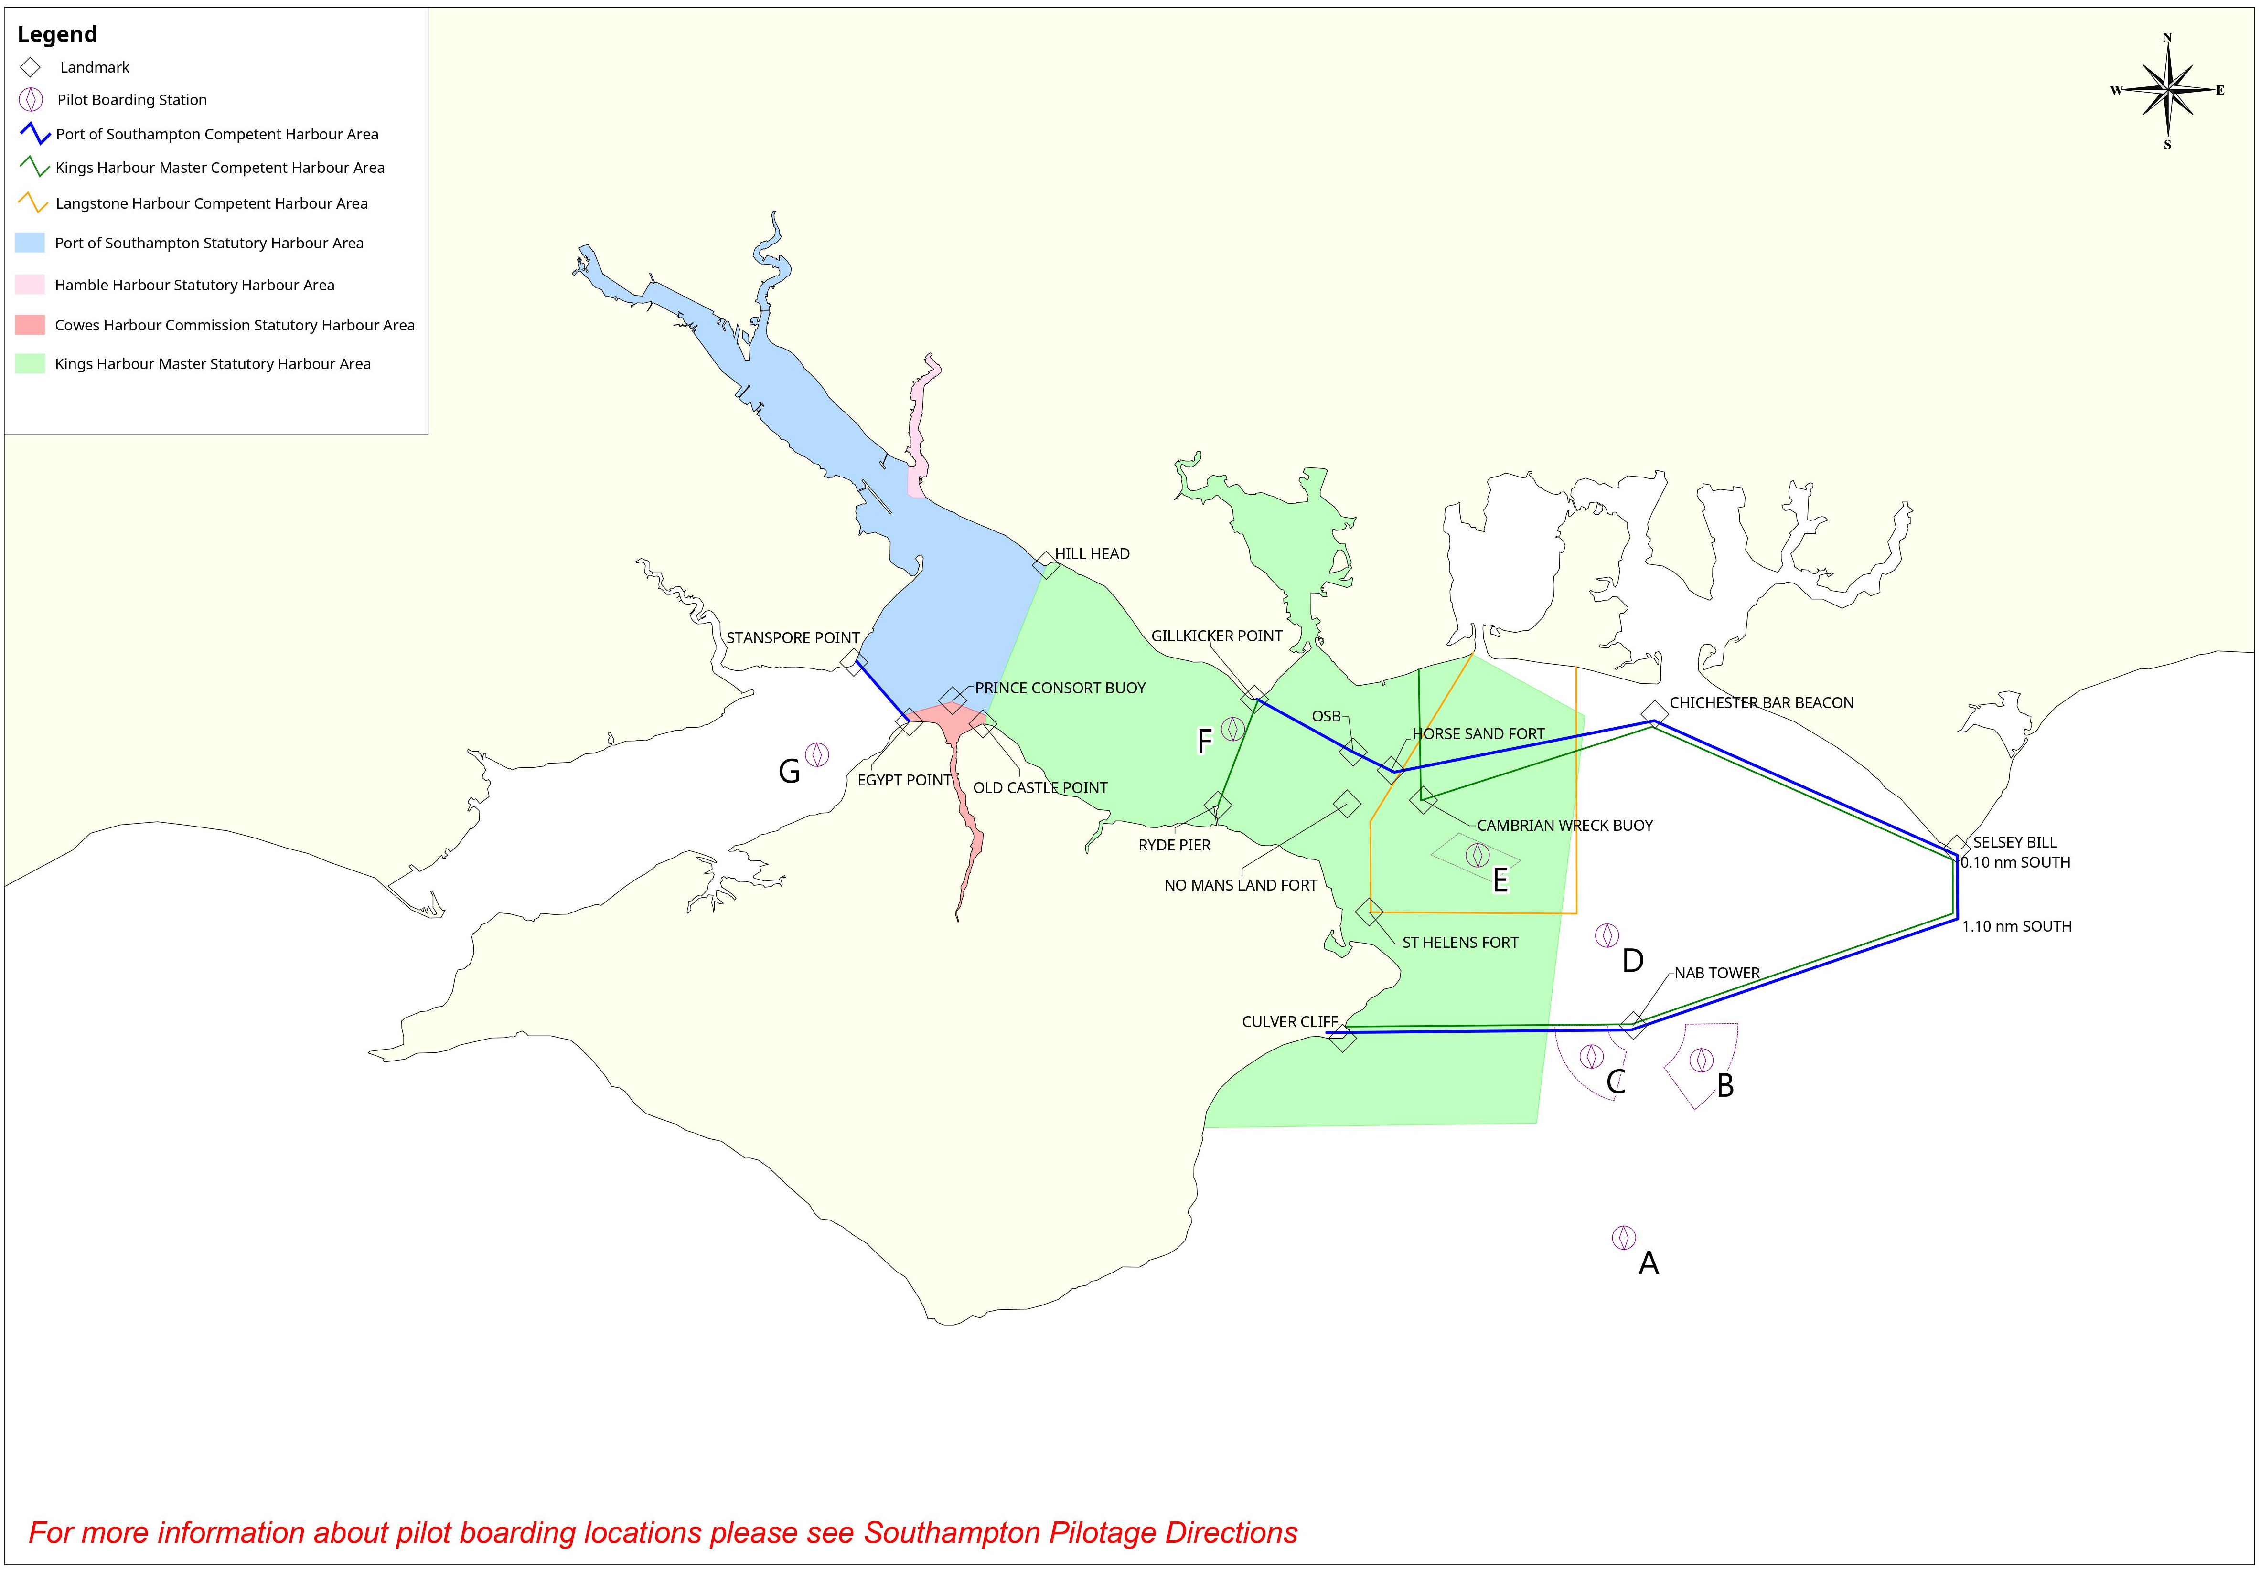
Statutory Harbour Authority and Competent Harbour Authority Limits

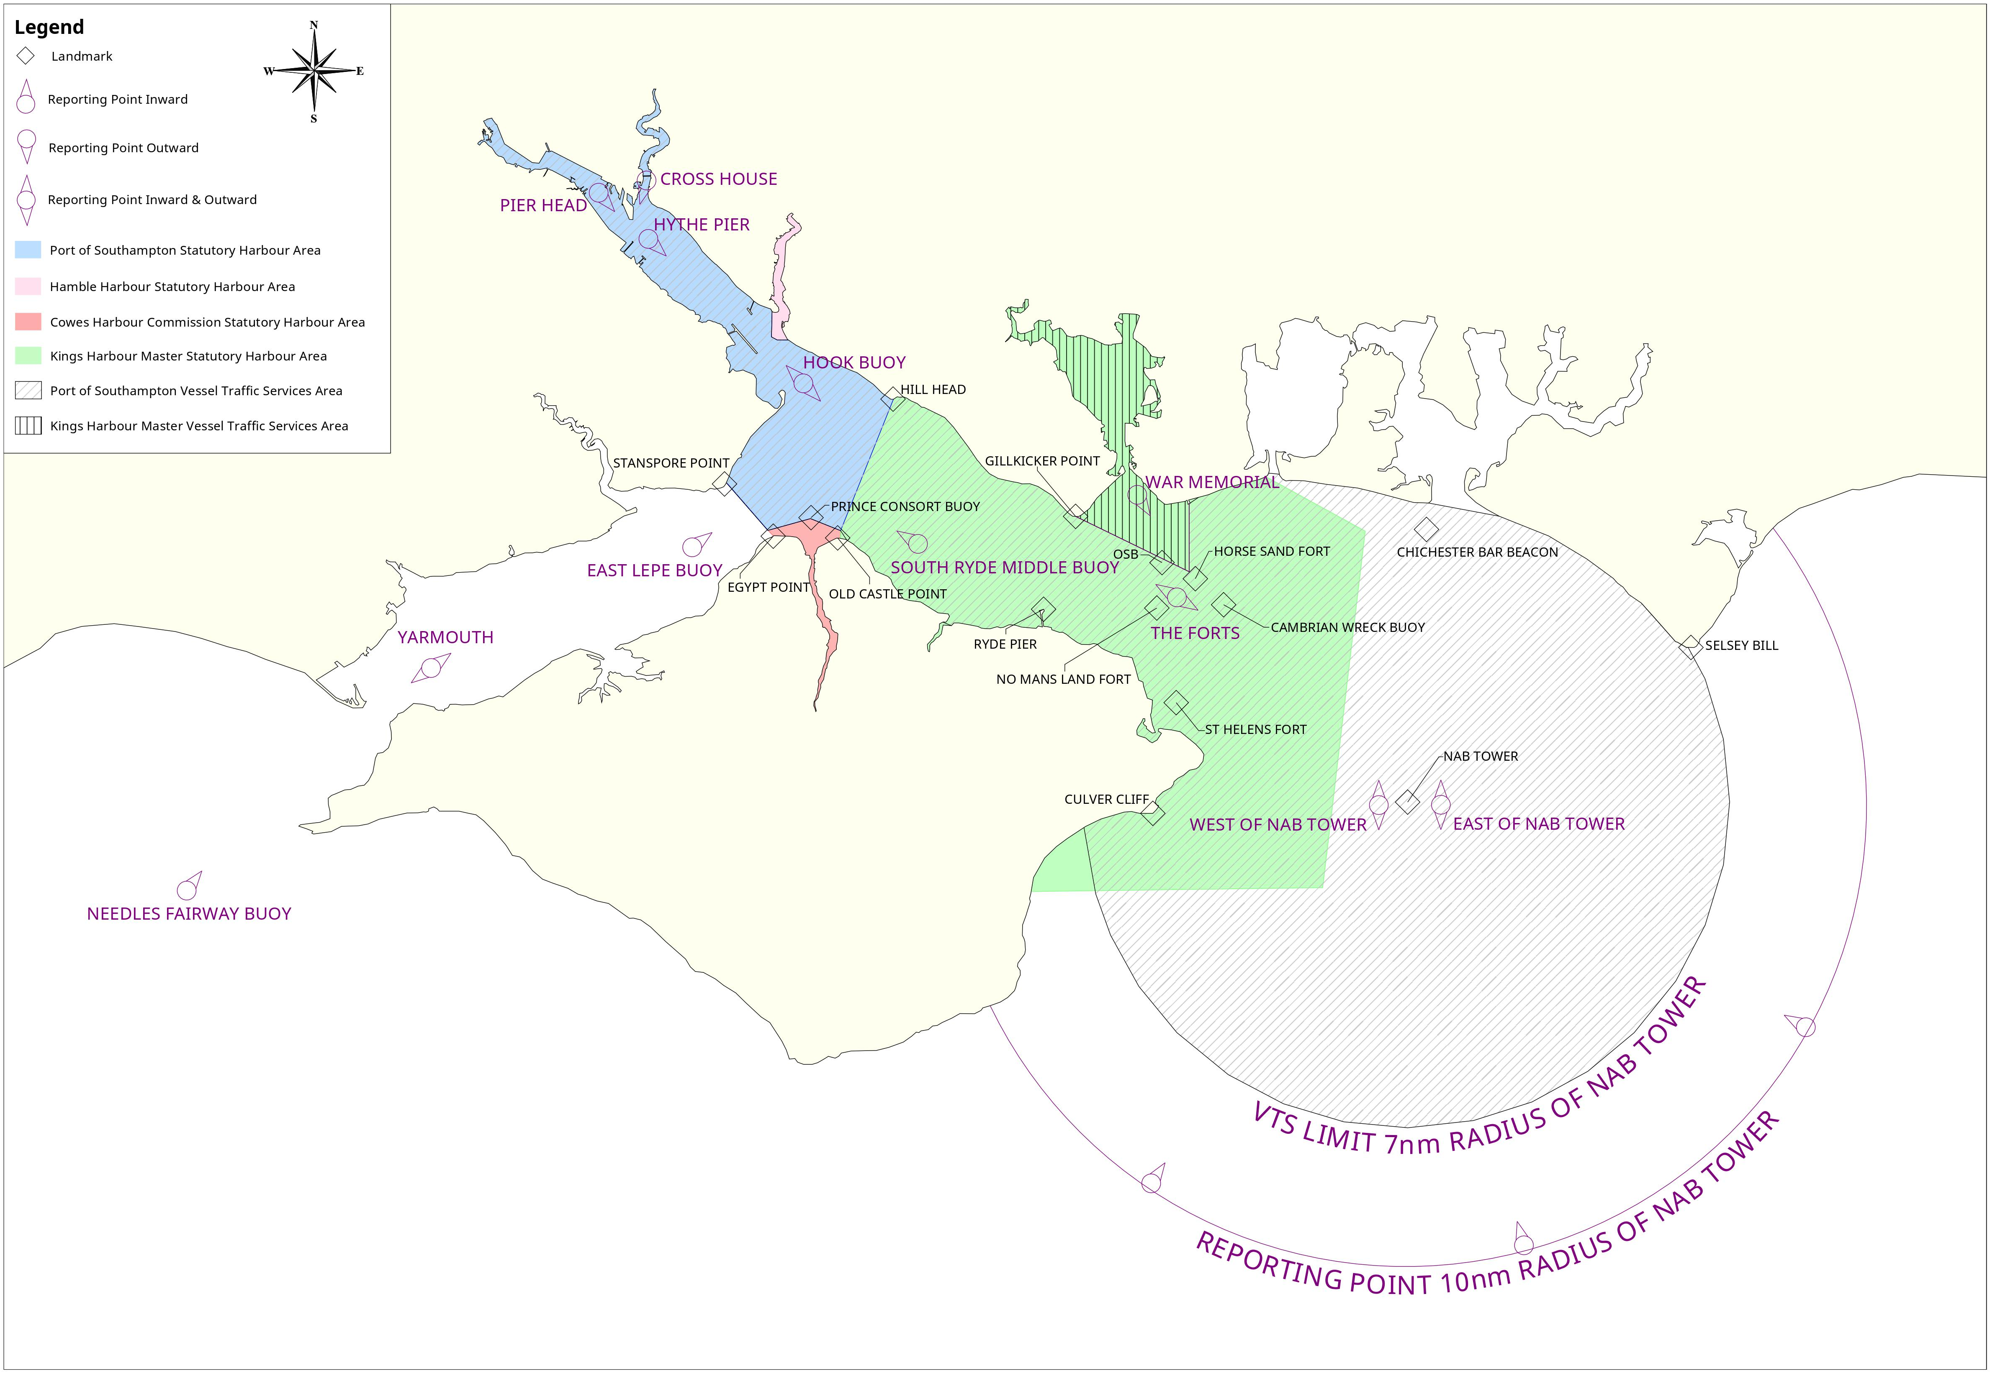
Statutory Harbour Authority and Vessel Traffic Services Limits

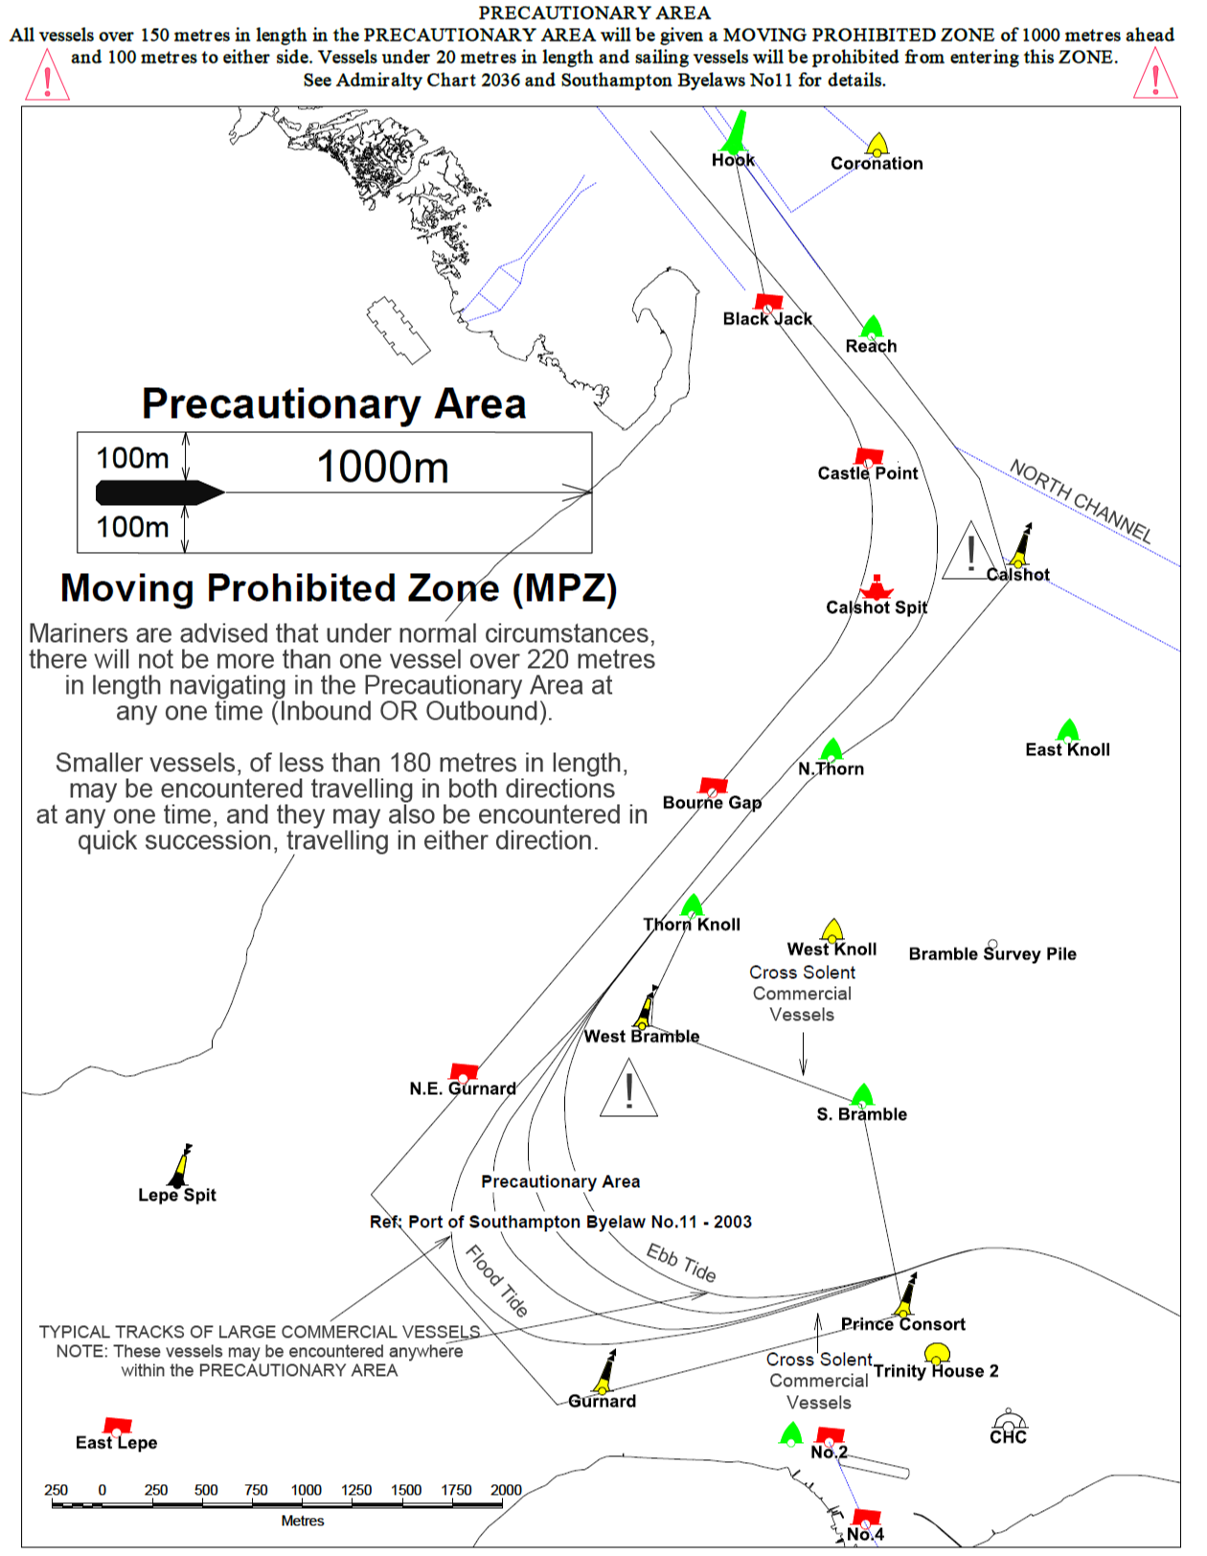
Precautionary Area (Moving Prohibited Zone)

Standard Passage Planning Times
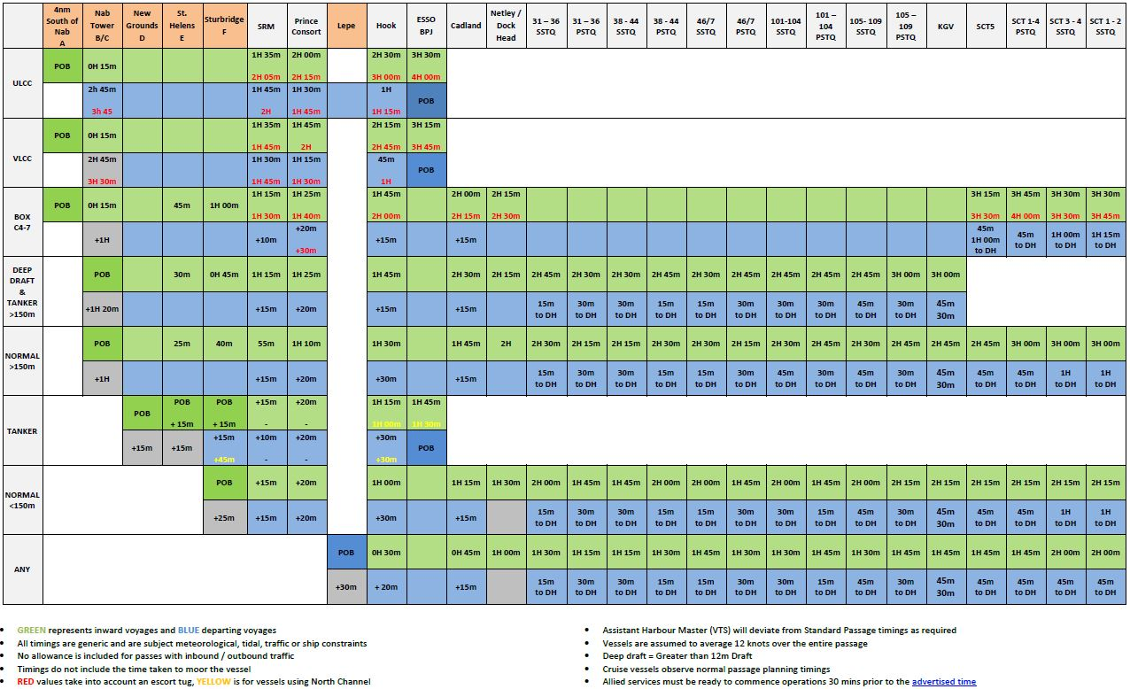

Estimated Bollard Pull Required (Chart)
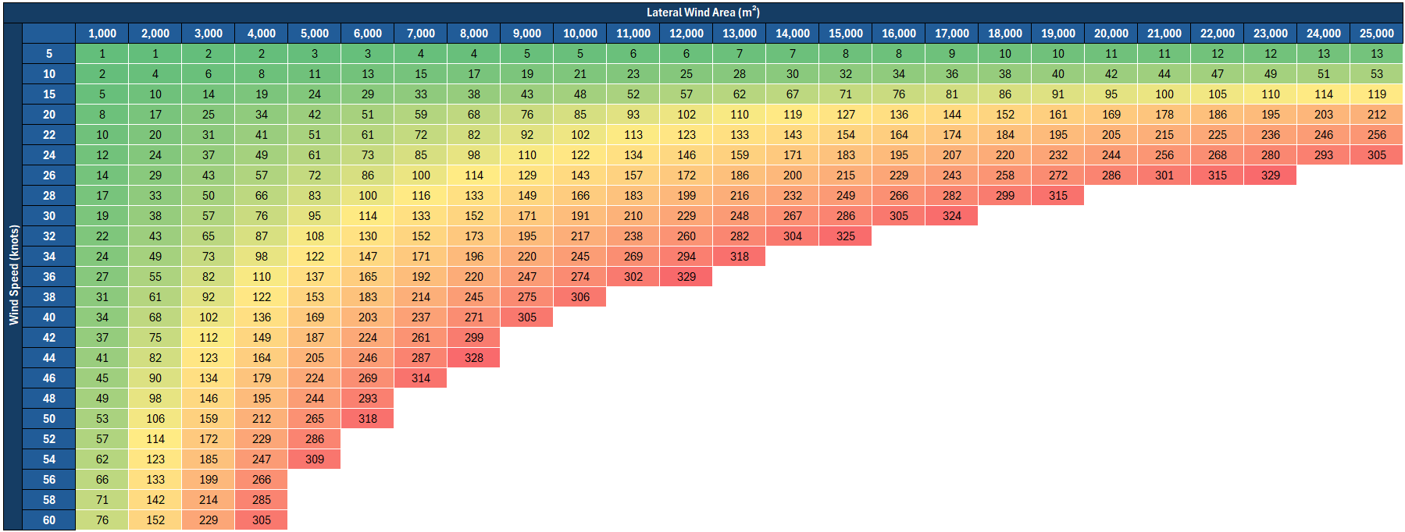
Cross Section of KGV Dock
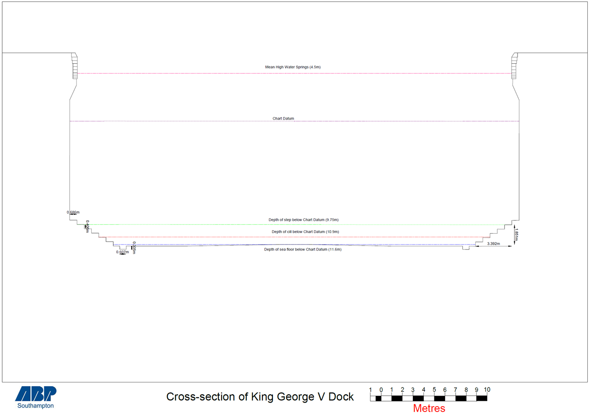

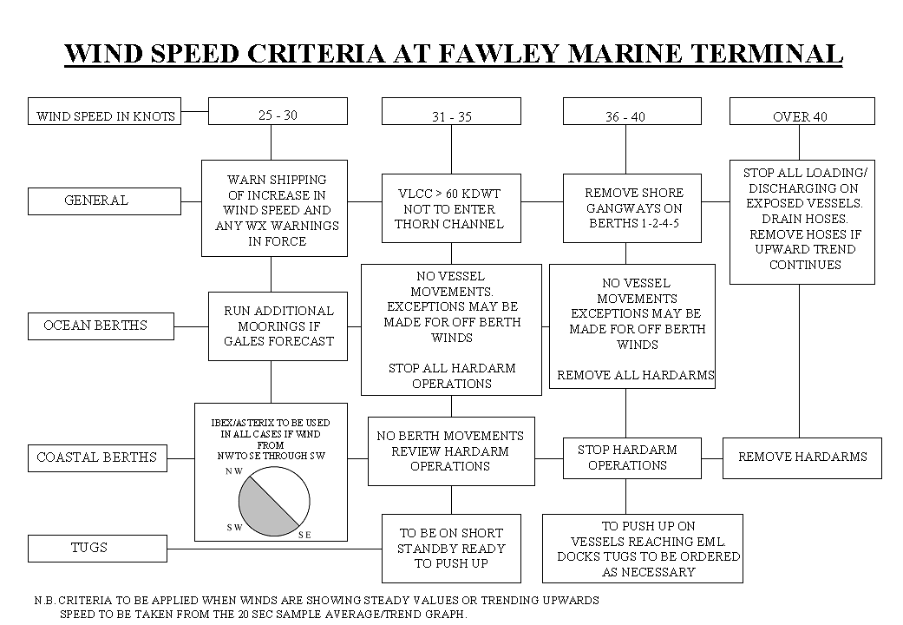Wind Speed Criteria at FMT

DPW Crane Information

Diagrams
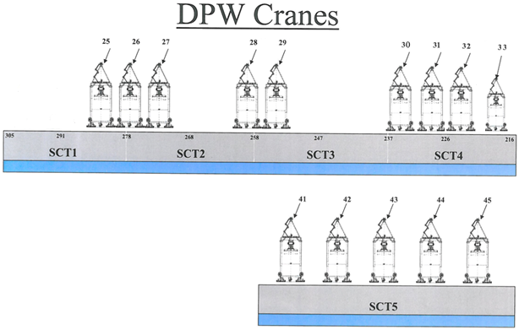

Table
Crane Name | Crane Make | Berth | Height of Jib (Above Quay) | Outreach from Quay Edge (Fender Face) | Outreach (Containers)
25 (H) | Liebherr | SCT 1-4 | 51.5m | 66.7m | 23
26 (G) | Liebherr | SCT 1-4 | 51.5m | 66.7m | 23
27 (F) | Liebherr | SCT 1-4 | 51.5m | 66.7m | 23
28 (U) | Liebherr | SCT 1-4 | 60m | 70.9m | 24
29 (V) | Liebherr | SCT 1-4 | 60m | 70.9m | 24
30 (E) | Liebherr | SCT 1-4 | 51.5m | 66.7m | 23
31 (D) | Liebherr | SCT 1-4 | 51.5m | 66.7m | 23
32 (M) | Paceco | SCT 1-4 | 40.4m | 57.5m | 20
33 (P) | Paceco | SCT 1-4 | 40.4m | 57.5m | 20
41 (C) | Liebherr | SCT 5 | 51.5m | 65m | 23
42 (Q) | Liebherr | SCT 5 | 54.3m | 68m | 24
43 (R) | Liebherr | SCT 5 | 54.3m | 68m | 24
44 (S) | Liebherr | SCT 5 | 54.3m | 68m | 24
45 (T) | Liebherr | SCT 5 | 54.3m | 68m | 24

SCT4 Distances to 203 Corner
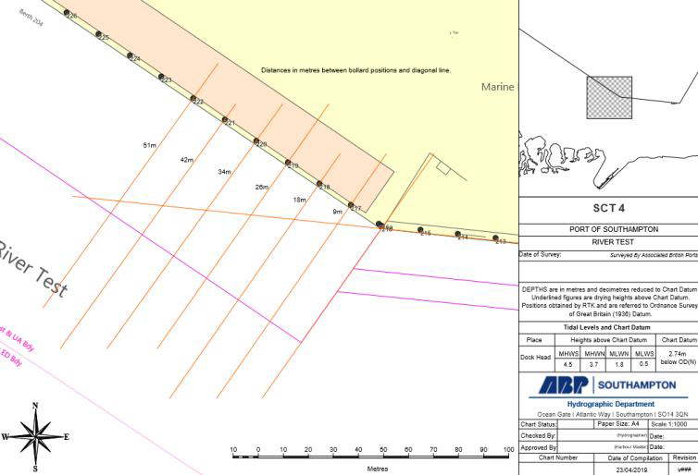

Solent Refit – Hythe Berth Depth Illustration
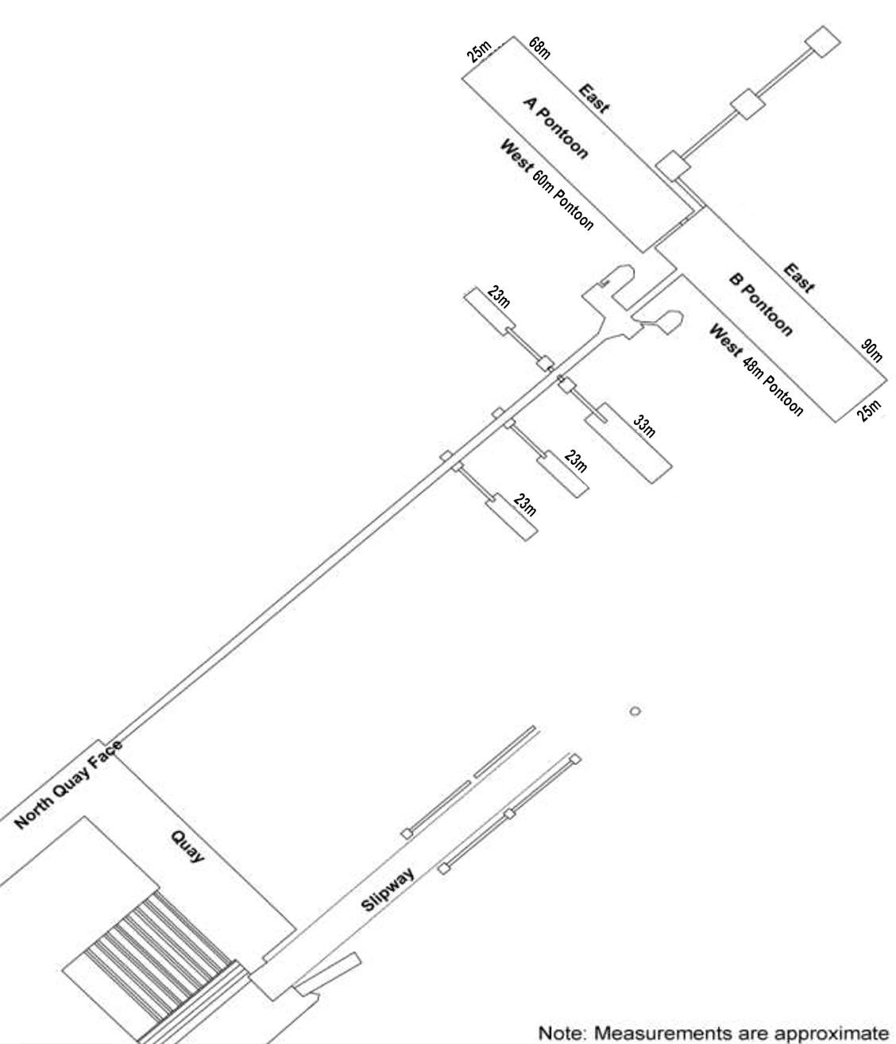

Fawley Mooring Plan Examples

FMT - Mooring Plan for Vessels Less Than 4,000 DWT

FMT - Mooring Plan for vessels 4,000 - 8,000 DWT (Version 1)

FMT - Mooring Plan for vessels 4,000 - 8,000 DWT (Version 2)

FMT - Mooring Plan for Vessels 8,000 – 12,000 DWT (Version 1)

FMT - Mooring Plan For Vessels Greater Than 12,000 DWT (Version 1)
Figure 1 – Esso Fawley berthing distance planning Sheet

FMT - Mooring Plan for Vessels Greater than 12,000 DWT (Version 2)

FMT - Mooring Plan for Vessels Greater Than 12,000 DWT (Version 3)

